جمهورية مصر العربية
معهد التخطيط القومي
الدراسات العليا
البحث التطبيقي


عنوان البحث باللغة العربية | الفرص والتحديات لتموين السفن بالوقود في منطقه قناه السويس  (في ضوء تجربه ميناء سنغافوره)
عنوان البحث باللغة الإنجليزية | Opportunities and Challenges for supplying vessels with fuel in Suez Canal zone  (Case study: Singapore port)
إعداد | محمد محمود محمد تركي
إشراف | د/ مها الشال  أستاذ الاقتصاد المساعد  مدير مركز التخطيط والتنميه الصناعيه

لاستكمال متطلبات
الحصول على الماجستير المهني "التخطيط للتنمية المستدامة"
2022

Abstract
The research aims to improve the activity of bunkering of ships in the ports located on the Suez Canal region, in order to attract local and foreign investments, and developing the necessary logistic services that Compliant with environmental requirements, which is considered one of the most important factors for the development of this activity, a like the largest global ports that operating in the vessel bunkering activity, and in order to achieve the objectives of studying, comparison methodology was used to figure out shortage in Egyptian market performance through analyzing the data of the largest global ports over world e.g. Singapore, Fujairah and Rotterdam.
The study concluded to the following results:
- Supply barges are one of the reasons for the drop of the bunkering supply activity, in terms of number and efficiency.
- The capacity of storage tanks causes an obstacle to the development of ship bunkering activity in the ports.
- The bunkering activity depends mainly on the governmental companies.
- The bad quality in service, quantity and timing of providing the service.
- Pricing inflexible and not competitive to the international prices
The most important recommendations reached by the researchers:
- Increasing the efficiency of the storage warehouses leads to improving the bunkering activity and increasing their storage areas.
- Improving in barges and increasing their capabilities in terms of: the storage area, pumping rate, heating and mixing, to become competitive, modern and competitive with followed in the global competing ports
- Interesting to the efficiency and conformity of the "barges" marine supply to environmental requirements and IMO regulations
- Introducing all facilities for service providers and including all of both privet sector, governmental and Public sector
- Applied international convention as per request of international maritime organization.
- Introducing the facilities for bunkering companies and all support from the government
- National law must be modified to attract more investments

Keywords: IMO2020, Bunkering hub ports, SC zone, Egyptian bunkering market, Singapore bunkering market

المستخلص
يهدف البحث إلى تحسين نشاط تموين السفن في الموانئ الواقعة على منطقة قناة السويس لجذب الاستثمارات المحلية والأجنبية ،
وتطوير الخدمات اللوجستية اللازمة المتوافقة مع المتطلبات البيئية والتي تعتبر من أهمها. عوامل تطوير هذا النشاط مثل أكبر الموانئ العالمية التي تعمل في نشاط تموين السفن ، ولتحقيق أهداف الدراسة تم استخدام منهجية المقارنة لمعرفة النقص في أداء السوق المصري من خلال تحليل بيانات أكبر الموانئ العالمية في العالم على سبيل المثال سنغافورة والفجيرة وروتردام.
وتوصلت الدراسة إلى النتائج التالية:
1- تعتبر بارجات الإمداد من أسباب تراجع نشاط تموين السفن من حيث العدد والكفاءة.
2- تتسبب سعة صهاريج التخزين في إعاقة تطور نشاط تموين السفن في الموانئ.
3- يعتمد نشاط التزويد بالوقود بشكل أساسي على الشركات الحكومية.
4- سوء جودة الخدمة والكميات وتوقيت تقديمها.
5- التسعير غير مرن وغير منافس للأسعار العالمية
أهم التوصيات التي توصل إليها الباحثون:
1- تؤدي زيادة كفاءة المستودعات إلى تحسين نشاط التزويد بالوقود وزيادة مناطق التخزين الخاصة بها.
2- تحسين السفن وزيادة قدراتها من حيث: مساحة التخزين ، ومعدل الضخ ، والتدفئة والخلط لتصبح قادرة على المنافسة ، وحديثة ، ومنافسة تليها في الموانئ العالمية المنافسة.
3- الاهتمام بكفاءة ومطابقة الإمدادات البحرية "للبارجات" للمتطلبات البيئية ولوائح المنظمة البحرية الدولية.
4- تقديم التسهيلات لمقدمي الخدمة وتشمل كل من القطاع الخاص والحكومي والعام.
5-تطبيق الاتفاقيات الدوليه الحديثه كما تنص المنظمه البحريه الدوليه
6- تسهيل الاجراءات لشركات تموين السفن وتقديم الدعم من قبل الحكومه
7-النظر في القوانين المحليه واعاده صياغتها لجذب مزيد من الاستثمارات

Table of contents:
Abstract 1
Table of contents: 3
Table of Charts 4
1-Theoretical Framework 5
1.1 Introduction 5
1.2 Research Problem 6
1.3 Research Aims and Objective 6
1.4 Importance of Research 6
1.5 Research Question 6
1.6 Research Methodology 6
1.7 Research Limits 7
1.8 Literature Review 7
2-Egyptian Bunker Market: Current situation 14
2.1 Current Situation in Egypt 14
2.2 Stages of Bunkering deterioration in Egypt 14
2.3 Pricing in Egypt 15
2.4 Characteristic of success in Egypt 16
2.5 Volume of trading 17
2.6 Opportunities 18
2.7challenges facing Egyptian bunkering market 19
3-Singapore 28
3.1 Introduction 28
3.2 Market overview 28
3.3 Volume of sales 28
3.4 The Reasons of success 30
3.5 IMO 2020 as a new challenge 31
3.6 A Singapore Guide For Bunkering Industry 31
Results and Recommendations: 32
Recommendations: 32
Suggested Researches: 33

Table of Figures
Figure1. MARPOL Annex VI NOx emission limits 22
Figure 2. MARPOL Annex VI fuel sulfur limits 24

Table of Charts
Chart 1: Monthly Number ship type in Suez Canal 18
Chart 2: Marine Fuel Sale 2014-2021 29
Chart 3: Market Size and Demand Forecast 2018-2026 30

List of Tables
Table 1: the prices of bunkering in Alexandria 15
Table 2: the prices of bunkering in Suez 15
Table 3: the prices of bunkering in Suez 16
Table 4: Monthly Number by ships that entering Suez Canal 17
Table 5: MARPOL Annex VI NOx emission limits 22
Table 6. MARPOL Annex VI fuel sulfur limits 24

1-Theoretical Framework

1.1 Introduction
Bunkering is the supplying of fuel for use by ships, and includes the logistics of fuel storage, handling and distribution until it is used on board.
Nowadays the term bunker is generally applied to the storage and delivery of petroleum products in tanks, and the practice and business of refueling ships. Bunkering operations are done alongside or offshore by specialized barges.
During the continuous economic and political changes, the most important change is the third technological industrial revolution and the World Trade Organization, which affected the movement of trade and with the increase in production, It is necessary to transfer these .products and open new markets ((Negm,2005،These changes had a significant impact on the transport sector in general and on the maritime transport sector in particular, and (Elgohary,2015). Maritime transport represents about 80% of the value of world trade (Elsheikh,2018).،Which led to the development of maritime transport and the development of the ship industry, and thus the development of bunkering activity in the world ports.
And the presence of the Suez Canal in Egypt, which is considered one of the largest and greatest navigational route in the world that considered the link point between the three continents Asia, Europe and Africa due to its unique and strategic position among the continents of the world, which made the Suez Canal the lifeblood of international navigation which reducing voyage time and reducing Operating costs for marine vessels, And the fuel cost is the most important costs which is used to operate the engines of these ships and Reducing fuel consumption, which represents 25% of the ship’s total expenses.
All of this led to the development of bunkering activity in the Egyptian ports, specially The two ports (Suez/Port Said) are located at the two entrances to the Suez Canal region, where Port Said port is located From the north side of the canal and overlooking the Mediterranean Sea to connect the continents of Europe and America with Asia and Australia through the Suez port on the Red Sea. And the strategic location of Suez Canal Economic Zone (SC zone) that provides service for all ships that passes through Suez Canal; nevertheless, it is a promising logistic Zone for investors.
The research aims to put Egypt in its proper position among bunkering market countries, and opens investments opportunities for bunker tycoons.
Alike Singapore, Al-Fujairah and Rotterdam ports, they invite for the use of a benchmark to an international marine service hubs, to provide high quality and standard fuel that complies with the international requirements.

1.2 Research Problem
Egypt does not exist on world bunker market map and the bunkering market in Egypt is not effective like Singapore, Fujairah and Rotterdam ports although the strategic location could help this business to grow up. However, Egypt has the factors that lead to success in bunkering market but there are many resolutions and rules obstacle the progress in this field.
There is a problem in quality and quantity control of bunker delivery in Egypt in addition to that most of the structure of hull of the bunker vessels are single hull, which cause a threat to the marine environment.
Therefore, Egypt needs to create an applicable methodology that encourages the investment in bunkering market.

1.3 Research Aims and Objective
- Understanding bunker market mechanism.
- Determine factors to control bunker market.
- Study international bunker market.
- Determine international main bunkering hubs and analyze their success stories.
- Determine the reasons of Egyptian bunkering market decay.
- Find out methodology to revive the Egyptian marine services market.

1.4 Importance of Research
The research is important for the national income; providing bunker hubs for ships through national bunkering companies i.e. essential to catch up with the dynamic industry changes; to design the mechanism and find out methodology to revive the Egyptian marine services market to contribute in the Egyptian GDP positively depending on bunkering services as a catalyst of all marine services.

1.5 Research Question
What are the main factors that lead to the success of bunker business in Egypt?
What are the obstacles that face bunker business in Egypt? How to solve them?
How to create a bunker market in Egypt?
What is the Egyptian rank among other countries in bunkering market?
What is the national law that related to Egyptian bunker market?
How to encourage more multinational investors to invest in Egypt?

1.6 Research Methodology
* The research uses the deductive reasoning,
*The research uses the Descriptive method Examine the literature related to the research topic
* The research uses the comparison study methodology to reach the objectives of the research, previous experiences of other countries e.g. UAE and Singapore that have same conditions, and resources, which lead them to be ranked in world bunker pioneers countries.

1.7 Research Limits
A-Time Limitation: the duration from 2003 to 2005 and from 2005 to 2021
.
B-Locational limitation: this study limited to the Suez canal zone(SC zone) ports because of the strategic location of these zones on Suez Canal.

1.8 Literature Review
A-Bunkering market in Egypt is not effective like Singapore, Fujairah and Rotterdam ports although the strategic location could help this business to grow up. However, Egypt has the factors that lead to success in bunkering market but there are many resolutions and rules obstacle the progress in this field.(Cutting Sulpher Oxide Emission , 2020), the results presented the importance of strategic location of Egypt and how can the government take advantage of this strong point in attraction more investments
B-This paper examined The word “Bunker” which is used extensively in defense forces and is used to define an area to store and safeguard personnel and supplies (such as ammunition, fuel, food etc.). It becomes derived from a Scottish phrase “Bunk” which this means a reserved seat or bench,(Anish, Bunkering is Dangerous: Procedure for Bunkering Operation on a Ship, 2021). And definition of bunker in the Maritime transport industry, the phrase bunker is used for fuel and lube oils, which are stored on a ship and used for machinery operation. If a ship is carrying marine fuel or lube oil to discharge it to every other port, it'll now not be called “bunker”. If the ship or truck is transferring it to another ship for the usage for its machinery, it'll be termed as “bunker” and the operation carried out to transport the oil is referred to as “bunkering”,(Anish, Bunkering is Dangerous: Procedure for Bunkering Operation on a Ship, 2021). The conclusion of this study shows the importance of knowing the main definitions for bunker and it’s being the main axes of this research that helps to know the challenges that research will discuss it’s solving.
While the ship gets any kind of oil for the usage of it in its machinery it is referred to as a bunker fuel or bunker oil. There are many types of bunkers which are provided to a commercial or passenger vessel like a Heavy fuel oil bunker, Diesel oil bunker, Marine gas oil bunker, Lube oil bunker and LNG fuel bunker. for example, The mega marine engines of ships burn tones of fuel every day in order to propel hugely loaded ships. those engines are recognized to use low-grade fuel oil to lower ship operating expenses as fees of fuel represents as much as 30-50% of total cost for operating ships.(Anish, Bunkering is Dangerous: Procedure for Bunkering Operation on a Ship, 2021), the results show the types of fuel and how the researchers do their best to develop in manufacturing a new engines to be comply with new world requirements and to be more economical through with low consumption of fuel that led to a cost control of operational fesses.
This paper aim to define the bunkering as in maritime law which in many maritime contracts, such as charter parties, contracts for carriage of goods by sea, and marine insurance policies, the ship-owner or ship operator is required to ensure that the ship is seaworthy. Seaworthiness requires not only that the ship be sound and properly crewed, but also that it be fully fuelled (or "bunkered") at the start of the voyage. If the ship operator wishes to bunker en route, this must be provided for in a written agreement, or the interruption of the voyage may be deemed to be deviation (a serious breach of contract). If the vessel runs out of fuel in mid-ocean, this also constitutes serious breach, allowing the insurer to cancel a policy and allowing a consignee to make a cargo claim. It may also lead to a salvage operation.(Ingpen, 2015),the results from definition regarding to maritime law ensure that the ship owner or operators are responsible for applying the conditions and terms of contract and any modification must be written in an agreement. Also, and any deviation will led to fines. So, the owner must be attention for these points.
Unfortunately(or fortunately), it’s not constantly possible to use low-grade fuels together with heavy fuel oil or HFO in regulated regions which is called ECAs or Emission control areas. Marine gas Oil fuel or MGO is one of the most prominently used clean fuels in such cases,(Anish, Bunkering is Dangerous: Procedure for Bunkering Operation on a Ship, 2021).
The Maritime transport industry is among the “early-adapters” inside the transportation area to expand and comply with stringent environmental legal guidelines if you want to Move shipment worldwide. Preventing air pollution from ships has been the top agenda for the Marine Environmental protection Committee, and consequently several policies were enforced to reduce the dangerous emissions from ships which include Sox and NOx,(Anish, Bunkering is Dangerous: Procedure for Bunkering Operation on a Ship, 2021).
With the ever-converting generation on ships, the fuel that is used to run marine engines is also (Network, 2021)converting rapidly. These days, LNG is being visible as the “future gas” for the transport industry, however, the industry as a whole is yet to adapt to this changes, and as a consequence Marine gas Oil continues to be one of the best favored clean fuel used on ships,(Anish, Bunkering is Dangerous: Procedure for Bunkering Operation on a Ship, 2021).
These results in above paragraphs are essential in research because it takes in consideration the environmental aspect and the rules that control the emission that get out from ships. Also it mentions LNG which will be the future fuel while Egypt has a new discovery from this type of fuel existing in Zohr field.
2-Ships trading in designated emission control areas will have to use fuel oil on board with a sulphur content of no more than 0.10% from 1st January 2015, against the limit of 1.00% in effect up until 31 December 2014. The interpretation of “fuel oil used on board” includes use in main and auxiliary engines and boilers. Exemptions are provided for securing the safety of the ship or saving life at sea or as a result of damage to a ship or its equipment. Also, provisions for trials for ship emission reduction and control technology research provide for a time limited exemption.(Network, 2021).
The research shows the definition of Emission control area which has special sulphur limit in the fuel used in ships during sailing in its area.
Marine Gas Oil used on ships is a blend component of the light cycle (gas) oil (LCGO) that contains about 60% aromatics. Due to the high aromatic nature, the density of marine gas oil blended with LCGO will be higher than the gas oil from an atmospheric distillation refinery. The density of MGO will usually be closet to 860 kg/m3 (at 15°C). And the marine gas oil is also considered as low sulfur fuel oil or LSFO because it has sulphur content between approx. 0.10 and 1.50 m/m %.(Anish, A Guide To Marine Gas Oil and LSFO Used On Ships, 2021).
The results presented MGO is suitable for the new regulation and its used is complying with the new requirements.
Taking in consideration that, Flag States must issue an International Air Pollution Prevention (IAPP) Certificate to the ship. This includes a section to state that the ship uses fuel oil with a sulphur content that does not exceed the applicable limit value as documented by bunker delivery notes; or uses an approved equivalent arrangement.(Network, 2021)
Ships taking on fuel oil for use on board should have a bunker delivery note, which states the sulphur content of the fuel oil supplied. Samples may be taken for verification. Port and coastal States can use port State control to verify that the ship is compliant. They could also use surveillance, for example air surveillance to assess vessel smokestack plumes, and other techniques to identify potential violations.(Network, 2021)
There are Sanctions for who will not be complying and these Sanctions are established by individual Parties to MARPOL, as flag and port States. There is no established fine or sanction set by IMO – it is down to the individual State Party,(Network, 2021)
The result presented the ability of emission control by revised the documented that contain the percentage of sulphur content in fuel and that ensure the quality control for the fuel enter the combustion chamber of engine. Also, inspection onboard ship by Flag state and port state to ensure the operating of ship in compliance with requirements and every party has its decision of sanction if the deficiencies are existing.
The stricter rules come into force under the International Convention for the Prevention of Pollution form ships (MARPOL) Annex VI (Regulations for the Prevention of Air Pollution from Ships), specifically under regulation 14, which covers emissions of Sulphur Oxides (SOx) and particulate matter from ships. These requirements were adopted in October 2008 by consensus and entered into force in July 2010,(Network, 2021).
The emission control areas established under MARPOL Annex VI for SOx are: the Baltic Sea area; the North Sea area; the North American area (covering designated coastal areas off the United States and Canada); and the United States Caribbean Sea area (around Puerto Rico and the United States Virgin Islands),(Network, 2021).
The results show that the rules and regulation that issued are control emission to reduce the pollution of the air. Also, some area has its rules that are shown stricter and obligated to ships that enter its ports to protect its environment.
Ships can meet the new requirements by using low sulphur fuel oil such as Marine Gas Oil (sometimes called distillates). An increasing number of ships are also making use of gas as a fuel as this contains no sulphur and when ignited leads to negligible Sulphur Oxide emissions. This has been recognized in the development by IMO of the
International Code for Ships using Gases and other Low Flashpoint Fuels (IGF Code), which has been approved in principle and is expected to be adopted in 2015,(Network, 2021).
Under “Equivalents” provisions also adopted in 2008, ships may meet the SOx requirements by using approved equivalent methods, such as an apparatus or piece of equipment (for example, Exhaust Gas Cleaning Systems or “scrubbers”, which “clean” the emissions before they are released into the atmosphere). In this case, the equivalent arrangement must be approved by the ship’s Administration (the flag State) that is a State Party to MARPOL Annex VI.(Network, 2021).
The results from paragraphs above showed that there are many ways to meet the requirements but, It is up to the ship operator to decide. If an alternative method is used, this has to be approved by the Administration (flag State) that is a State Party to MARPOL Annex VI.
Natural gas offers lower local pollution emissions compared to distillate fuels. For NOx emissions, current engine designs equal those of distillate fuels, and proposed improvements to engine design may reduce emissions to meet Tier III levels without after treatment. Research indicates that the SOx and PM emissions of natural gas meet current, pending, and proposed standards for marine vessel operations and can significantly reduce local pollutants from vessel operations. Second, price differences between natural gas and low-sulfur fuel oil since 2002. (IEA, 2012) suggest an economic advantage may favor natural gas. An increasing number of newly constructed vessels are powered either by natural gas exclusively or by a combination of conventional diesel and natural gas. Market-ready reciprocating internal combustion marine engines capable of natural gas and/or dual fuel operation enabled multiple shipbuilders to install these engines. In addition, natural gas infrastructure is growing (Full Enbaum et al., 2013), making it more plausible to fuel ships with natural gas. These two drivers – the need to comply with ECA regulations and the competitive market for natural gas fuel – highlight a surge in interest in the use of natural gas as a marine fuel, (Heather Thomson, 2015).

The results presented the importance of the LNG as fuel because it suitable in cost and cover the new requirements of Convention because it is consider the best fuel for ships from cost, effect on environment and its effect on engines of ships. This study indicates that the future fuel is LNG and after the new discovery in ZOHR field, Egypt became one of the countries in the Mediterranean Sea that export the gas for many countries.
If a ship is switching fuel as it goes into an emission control area then this needs to be done safely and cleanly, to avoid any technical problems and to ensure that the emission limits are not breached inside the ECA,(Network, 2021).
MARPOL Annex VI regulation 4.6 requires ships using separate fuel oils to carry a written procedure showing how the fuel oil change-over is to be done, allowing sufficient time for the fuel oil service system to be fully flushed of all fuel oils exceeding the applicable sulphur content prior to entry into an Emission Control Area,(Network, 2021)
The volume of low sulphur fuel oils in each tank as well as the date, time, and position of the ship when any fuel-oil change-over operation is completed prior to the entry into an Emission Control Area or commenced after exit from such an area, must be recorded in such log-book as prescribed by the Administration. Industry organizations have issued guidance notes on the need for care and attention when switching fuel, to avoid any potential problems that could result from fuel switching,(Network, 2021)
The conclusion of this study was oriented the methodology in ships that using separate fuel oil and showed how the important procedures must be followed to avoid any emission.
Widespread uptake of Liquefied Natural Gas (LNG) fuelled ships would require the development of infrastructure, including terminals, and LNG storage facilities (with/without liquefaction capabilities). Currently, most production plants and LNG import terminals are designed to service full sized LNG carriers and are not equipped to serve smaller vessels, or to frequently receive ships. Existing LNG terminals would therefore require modification to refuel ships. LNG can also be supplied by trucks, provided the volumes required are relatively small. The costs of LNG terminals for ship refueling can be high. Taking into account different scenarios, the study cites average infrastructure costs of €170 per tonne of LNG in the cost analysis compared to 10 €/tonne for existing HFO and MGO infrastructure. This is a very significant difference; if it is funded from the public purse it constitutes another fossil fuel subsidy,(Raptis, 2016).
The results show the high cost of infrastructure for terminal and LNG storage facilities and revue that come after starting in supplying vessel with the LNG fuel.
Rapid progress has been made worldwide in recent years in the discovery of new NG deposits. Its increased availability, the need to meet increasingly lower engine exhaust emission controls, and its relatively low cost have tended to increase its usage as a fuel in a wide variety of applications. The gas has been increasingly viewed as a premium fuel that is in much demand, and may well be for quite some time in the future a prime source of usable fuel energy,(Žaglinskis, Rapalis, & Lazareva, 2017).
This study ensures the importance of LNG as fuel in the future. Because of the impact on environment and on engines of ships is the less.
This study shows the pioneers future and plans for Egypt and how great the benefit if the government expands its exports to Europe. This expands will led to increase the national income To Egypt.
The recent discovery of the Zohr field may be considered one of Egypt’s most significant natural gas findings in the Mediterranean Sea. The field is considered to be the largest natural gas reservoir ever found in the region as it has an estimated 30 trillion cubic feet (Tcf) of gas with almost triple Egypt's gas reserves (BP, 2020). According to a recent governmental announcement (Feb-2020), the Zohr field production has increased to a current 3 billion cubic feet per day. Egypt, currently, has two natural gas liquefaction sites on its Mediterranean coast in Dumyata and Idko Additionally; a third site is located in Ain Sukhna in the Gulf of Suez area, (Yasser B. A. Farag, 2020).
The results show the strong discovery in the Mediterranean Sea and Egypt became hub port and destination for export LNG for countries.
Strategically located on the Eastern seaboard of the United Arab Emirates, approximately 70 nautical miles from the Straits of Hormuz, Fujairah is the Middle East’s leading energy hub location for oil trading, storage, and bunkering.
The Port of Fujairah in particular has grown exponentially, strategic investment in; infrastructure, facilities and comprehensive support services has enabled the port to keep abreast of the various trade and industry developments, market demands and establish the ports reputation as a globally renowned safe, efficient and progressive hub location.
The UAE’s premier hub location for Bunkering & Oil Trading activities, specifically designed to safely and efficiently handle the high volume of crude oil and refined products imported / exported by the 13 international recognized terminal storage companies, which are directly connected to the port. The Port of Fujairah offers total flexibility to the terminals by providing them access to any of the berths within FOTT or direct transfer of products between terminals without chartering a vessel via two matrix manifolds,(The 8th Gulf Intelligence Energy Markets Forum 2018, 2018).
This paper aim to explain the importance of strategic location of the United Arab Emirates in which a lot of investments were established and after that this business revue a national income for the country Thus, Egypt have strategic location that must be benefit from it to be one of the best marine service center in middle east like United Arab Emirates.
The deep and safe waters off Fujairah proved to be the ideal location for gathering vessels, prior to entering the Gulf. Fujairah’s location on major shipping routes and about 70 nautical miles from one of the key international shipping routes for tankers, meant that it could provide ships with fuel for their onward journeys as well as oil storage services, effectively enabling tankers to load without necessarily entering the strategically sensitive strait. Tanker operators loading at Fujairah would also save their vessels sailing hours by avoiding the strait,(Policy in Action, 2016).
The conclusion of this study shows the factors that helps success this activity of bunkering in Fujairah. And this study help the research explain the factor that led to success in the Egyptian case.
Fujairah is not the only place eyeing the role of LNG bunkering hub. Last year, Oman signed an agreement with France’s Total that includes the possibility of establishing an LNG bunkering unit in the port of Sohar. “An increasing number of new ships are choosing LNG as a fuel and LNG bunkering could be quite a differentiator for Fujairah and make sure they are on the global network of LNG bunkering hubs, that could be one way of attracting volumes,” said Wood Mac’s Gelder. “LNG as an industrial fuel, that could be a good thing for companies in that region because they should have access to relatively low cost and relatively clean fuels which enhances their competitive position.”,(Saadi, 2019)
This study show the variety in providing service and variety in providing many types of fuel like LNG that comply with the global requirements, cover the needs of bunker market and doesn’t cause air pollution.
Singapore-based shipbuilder Keppel Offshore & Marine Ltd (Keppel O&M) has delivered Singapore’s first liquefied natural gas (LNG) bunkering vessel, FueLNG Bellina, to FueLNG,.
Built in Keppel O&M’s Nantong shipyard, FueLNG Bellina is the second LNG bunkering vessel and fifth dual-fuel vessel delivered by Keppel O&M.
Keppel said the delivery was in line with its Vision 2030, which includes seizing opportunities in LNG solutions and renewables,(Keppel Delivers FueLNG Bellina, Singapore’s First LNG Bunkering Vessel, 2021).
The results presented the new building in Singapore and the vision that reflect the future fuel that will be used as marine fuel instead of traditional fuel. Egypt has a big field for production of natural gas in Mediterranean Sea. Thus, the new building ships will need this production as fuel for its operation.
Singapore, the world’s largest marine refueling hub with annual sales volumes of about 50 million tons of bunkers, is the only port globally that implements a licensing regime for bunkering suppliers and craft operators. Singapore, which has provided more than 270 truck-to-ship LNG bunkering services this year so far, is likely to offer its first ship-to-ship LNG fuel transfer by the first quarter of 2021 and a total of about 300 STS LNG bunkering operations, Chee said,(Khasawneh, 2021).
The results show the volume of sales of bunker in Singapore and it is related to the good facilities that provide to the bunkering suppliers.

2-Egyptian Bunker Market: Current situation

2.1 Current Situation in Egypt
Egypt is not existing on world bunkering map however the strategic location and the available resources that could make Egypt competitive market in bunkering.
The specialist companies in bunkering have left the Egyptian market because of lack of good benefits and bureaucracy of national laws, regulations, rules and instructions that issued by the Egyptian government. Also, there are a lot of technical issues related to the international regulations that have been issued recently.
Thus, Egypt needs to create an applicable methodology that encourages the investment in bunkering market. And setting a proposal if it was applied, a big market will be opened in Egypt like Singapore, Rotterdam and Fujairah. Also, the government needs to provide all facilities for bunkering companies to work in Egypt.
There are many problems that led to the deterioration of bunkering market in Egypt.and the research the shadow on these problems to explain why the bunkering market in Egypt isn’t the perfect. And, In order to develop the bunkering market in Egypt, we should study the following:
- The stages of bunkering deterioration in Egypt.
- The characteristic of success in the Egypt.
- Challenges facing Egyptian bunkering market

2.2 Stages of Bunkering deterioration in Egypt
The deterioration of bunkering took a lot of time to be the worst and this part illustrates the reasons of failure in the previous period before the year 2005 and how the lack of activities was obvious clearly in ports and at this time.
The government companies and international companies have taken the permission for working on bunkering activities like Total and ExxonMobil companies, etc. And the amount of sale for the bunkering was 3.5 ton annually. Also, bunker was supported for all of the national and international companies and the Egyptian companies had its share and its fleet was raising the Egyptian flag.
After that at the year 2005Mac Oil Company was the only company that works in bunker business in all the Egyptian ports led to the poor service in bunkering, so the ships started to look for alternatives of bunkering from other ports over the world.
Then After the year 2005 the government had issued a decision exclusively for Egyptian companies like Misrpetroleum and Al-Taawon that these two companies will be the only ones to provide bunker services.
At the year 2016Ministerial Decree No. 800 for the year 2016 has issued.
The Egyptian Government issued the resolution No. 800 that certify that the companies that provide bunkering services must pay to the government 20 USD for each ton from it sell and transport in addition to 14% extra value, which is equal 4 USD and hence the total cost is 24 USD. Meanwhile, a bunkering company was earning 1.5 USD for each ton.
Thus, this decree wasn’t correct and led to the poor service and lack of competition in time, amount and quality in comparison with other global centers. At the same time the Limited amounts and time: lack of client request and bad quality.

2.3 Pricing in Egypt
The pricing policy is not flexible and not competitive and the governmental purchasing and selling policy is not perfect that leads to the disability of companies to make a competitive price.
The policy of pricing is related to the regulations, resolution and law that control dealings in bunker business and lacks the ability of instant pricing (stock market) like the same world price.
Table 1: the prices of bunkering in Alexandria
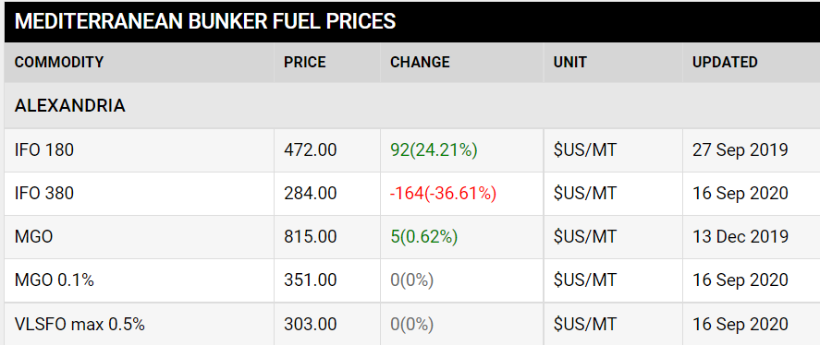
Source: oil monster website

Table (1) shows Last updated prices for bunker in Alexandria port between the period from September 2019 to September 2020to make comparison in sales with other ports. Last updated prices for bunker in Alexandria port was September 2021 because of the lack of bunkering market and service in Egyptian ports.

Table 2: the prices of bunkering in Suez
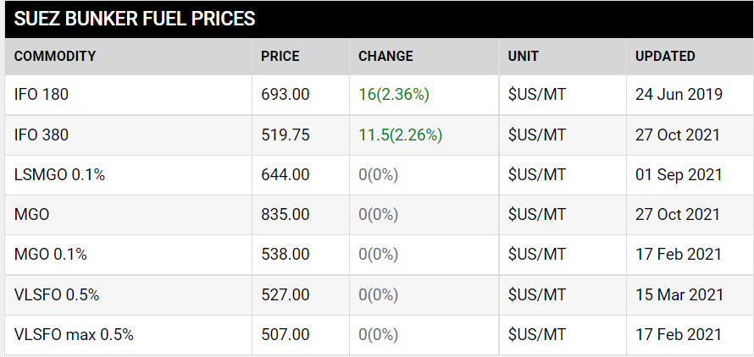
Source: oil monster website

Table (2) shows Last updated prices for bunker in Suez port between the period from June 2019 to October 2021to make comparison in sales with other ports.
Last updated prices for bunker in Suez port was October 2021 because of the lack of bunkering market and service in Egyptian ports.

Table 3: the prices of bunkering in Suez
Bunkering Sales: million tonne/meter
Volume of sales | Egyptian ports | SINGAPORE | FUJAIRAH | ROTTERDAM
2003/2004 | 2.90 | 24 | 8 | 12.3
2018/2019 | 0.50 | 47.5 | 9 | 9
Source: reports for the Egyptian General Petroleum Corporation - and websites

Table3 shows the significant decrease and the clear difference in the volume of sales, despite the existing the characteristics of success of the Egyptian ports.

2.4 Characteristic of success in Egypt
International navigation route and about 18,000ship pathway and about 5000 ship sailing between the ports of authorities Port Said, Suez, Ismailia and other ports. The time the ship spends in anchorage area is suitable for providing many of the services and because the waiting time is about 8 hrs. And the bunker process takes time from 4 to 6 hour,(SCA, 2019).
The existence of a previous market in the authority ports ( Port Said, Suez, Ismailia) bout 2.5 to 3 ton yearly. Suitable weather conditions all of the year helps providing a smooth bunker service,(SCA, 2019).
After the dredging the new Suez Canal, it was a big push for encourages the investment in Suez Canal area because the following:
1- Increase the daily average of transiting vessels to 97 ships by the year 2023, up from 49 ships at present;(SCA, 2019).
2-Achieve direct unstopped transit for 45 ships in the two directions, and stepping up the permissible draft to 66ft all through the Suez Canal;
3- Increase the Suez Canal revenues from $ 5.3 billion at present to $ 13.226 billion in 2023; an increase equal to 259% that shall positively contribute to Egypt’s national income of hard currencies;
4-Create job opportunities for young people living at the Canal Zone, Sinai, and neighboring governorates; and creating new urban societies as well; and
5-Maximize competitiveness of the Suez Canal, excel its ranking among other alternative canals, and world classification societies due to the high rate of safety accomplished during transits,(SCA, 2019).

2.5 Volume of trading
The economics of maritime transport as one of the branches of the economy was and still is the focus of attention of many developing and developed countries in general and Egypt in particular, where maritime transport is one of the cheapest methods of transport in addition to its ability to cover large areas of the world, especially in the Arab Republic of Egypt. Moreover, it has a strategic location geographically which is in the middle of the Arab world.(Rasoul, 2022).
The maritime industry plays an indispensable role in global trade and economic development, all commercial and maritime sectors depend on the services and capabilities provided by the shipping sector to facilitate the supply chain cycle from door to door, Therefore, the efficiency of maritime sector services is a major focus in the competitiveness of any economy and its ability to achieve economic growth, and attract foreign investment to the country.(Rasoul, 2022).
Table 4: Monthly Number by ships that entering Suez Canal
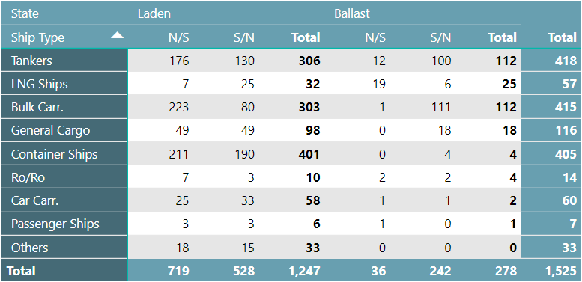
Source: Suez Canal Authority Website (Monthly Number & Net Ton by ship type)

Table 4 shows the different types of ship and their numbers during entering the Suez Canal (from north to south) and (from south to north). on Feb,2020 the total number was 1525 ship and the tankers ships was the most number of ships that entering Suez Canal with 418 ships.at the same time, passenger ships was the least number of ships that entering Suez Canal.

Chart 1: Monthly Number ship type in Suez Canal
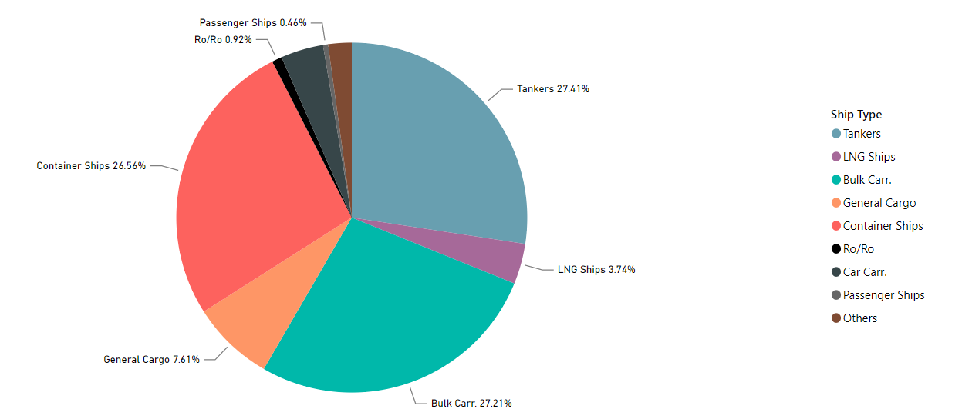
Source: Suez Canal Authority Website (Monthly Number & Net Ton by ship type)

The chart explain that tanker ships represent the highest number of ships with percentage
27.41 % and the passenger ship the least number of ships with 0.46%.

2.6 Opportunities
As mentioned above, the existing of the characteristics of success of the Egyptian ports that Egypt in top rank among countries that working in bunker activity. Where an average of 50 ships cross the Suez Canal daily and about 18, 174 thousand ships annually in both directions,(SCA, 2019).and which the navigation system in the canal leads to waiting the ships of the northern convoy from Port Said for few hours, which the convoy begins at 03:30 Am coming from Europe and America From the entrance of the canal from the side of Port Said port, then followed by the passage of the ships of the southern convoy from the side of the Suez port - which begins at 04:00 AM coming from Asia and Southeast Asia which is currently considered the World Trade Center to all countries of the world and Australia, the waiting may now reach about 5 hours instead of 12 hours, as this period has been greatly reduced after the dredge works of the new channel’s in August 2015,(SCA, 2019).
SO, theses waiting ships must be provided with services Also, with offering competitive selling prices to neighboring ports and granting some advantages to the ships that get bunker fuel , like the case in some other international ports may give a great opportunity to request and provide many services for these ships, including fuel bunker (diesel and diesel), to That helps the agent of these ships avoids waiting to other days to get bunker fuel in the anchorage waiting area or in another port, which enables him to reduce operating costs, and it is one of the basics of operating economics, as the rental cost of these ships, and their daily operating costs, reach large sums depends on the type of ship, its cargo and the year of manufacture And course.

2.7 challenges facing Egyptian bunkering market
Egypt is not existing on world bunkering map however the strategic location and the available resources that could make Egypt competitive market in bunkering.
There are many problems that led to the deterioration of bunkering market in Egypt as the following:

2.7.1 Legal aspect
A- The national laws which are issued from the Maritime administrations, or flag state administrations, are the executive arms/state bodies of each government responsible for carrying out the shipping responsibilities of the state, and are tasked to administer national shipping and boating issues and laws within their territorial waters and for vessels flagged in that country, or that fall under their jurisdiction.
The Egyptian national law of issued by the government that led to deterioration of the bunker market and the unstudied decisions that have taken make the companies owner to leave the Egyptian market. For example some of resolutions have issued which were a part of causes of deterioration of bunkering market in Egypt as like the following:
Fuel prices delivered in Egypt is far higher than the international average, while the quality is not that reliable so, Resolution No. 20 of 1976 the Minister of petroleum is needed to be modified.
Moreover, regarding to activities of maritime transport, Resolution No. 800 of 2016 the Minister of Transport is required to be modified as well.
Furthermore, there are a lot of problems that face the ships in ports specially the prices of service of ships. Resolution No. 488 of 2015 the Minister of Transport is needed to be modified.
Thus, theses national laws must be modified by the government. Also, to develop the government must give more benefits and facilities to attract the international companies that work in this field to get more investments.
B-International legislation established by the International Maritime Organization (IMO), which is the United Nations specialized body in charge of shipping safety and security, as well as the prevention of marine and atmospheric pollution by ships. The activity of the IMO contributes to the UN's Sustainable Development Goals. Consider the following scenario:
1-The International Convention for the Prevention of Pollution from Ships (MARPOL) is focused with preventing maritime pollution caused by ships. Annex VI of MARPOL specifically covers air pollution from ocean-going ships. Annex VI's international air pollution rules set limits on nitrogen oxides (NOx) emissions and mandate the use of low-sulfur fuels, protecting people's health and the environment by lowering ozone-producing pollution, which can produce smog and aggravate asthma.
2- IMO 2020: On January 1, 2020, a new sulphur content limit for fuel oil used on ships went into effect, marking a huge step forward in improving air quality, preserving the environment, and safeguarding human health.
The guideline, known as "IMO 2020," reduces the amount of sulphur in fuel oil used on board ships operating outside of authorized emission control areas to 0.50 percent m/m (mass by mass), down from 3.5 percent previously. The limitations were already tougher within particular designated emission control areas (0.10 percent). Following a modification to Annex VI of the International Convention for the Prevention of Pollution from Ships, this new limit became mandatory (MARPOL).
Egypt isn’t applied for Annex VI from MARPOL Convention that related to air pollution so; the existing fuel is not high standard fuel and isn’t complied with the global requirements.

2.7.2 Logistic aspect
It is represented by the requirement for the logistics required to execute and deliver the service. Supplying ships should be modern, of varied sizes, with a high rate of thrust, and equipped with all services in the best and quickest way feasible, and the current maritime supply bunkers (barges). And the availability of storage warehouses large enough to hold enormous amounts, allowing for the import of large quantities at a reasonable cost.
Egypt should give priorities the construction of new barges or bunker supplies in order to have a large enough fleet to perform several bunkering services at the same time and efficiently.

2.7.3 Environmental aspect (SOX & NOX)
The two main pollutants from the ship’s emission are Nitrogen oxides (NOx) and Sulphur oxides (SOx). These gases have adverse effects on the ozone layer in the troposphere area of the earth’s atmosphere which results in the greenhouse effect and global warming. Both NOx and SOx are combustion products that are emitted in to the environment in the form of smoke.
There are environmental problems because of the emission that produced from ships due to the bad quality of fuel bunker and its contents (SOX and NOX) that finally led to the air pollution and this known as problem of Quality control.

2.7.3.1Quality Control
One of the problems is the quality control which the high percentage of contents of SOx and NOx in bunker fuel that is below the requirements of customers. And the fuel in Egypt isn’t complied with the requirements of low sulphur and emission control.as mention below.
And to explain the problem of quality control, research should shows the emission control areas and its requirements, low sulphur, NOX, SOX, and emission control limit as the following:
A-Emission Control Areas: Annex VI specifies two sets of emission and fuel quality rules: (1) global norms and (2) more rigorous requirements for ships operating in Emission Control Areas (ECA). Subject to a proposal by a Party to Annex VI, an Emission Control Area can be defined for SOx and PM, NOx, or all three types of emissions from ships.
Existing Emission Control Areas include:
- Baltic Sea (SOx: adopted 1997 / entered into force 2005; NOx: 2016/2021)
- North Sea (SOx: 2005/2006; NOx: 2016/2021)
- North American ECA, including most of US and Canadian coast (NOx & SOx: 2010/2012).
- US Caribbean ECA, including Puerto Rico and the US Virgin Islands (NOx & SOx: 2011/2014).
B- Greenhouse Gas Emissions. MARPOL Annex VI was amended in 2011 to include necessary measures to reduce greenhouse gas emissions (GHG). The Amendments included a new Chapter 4 to Annex VI, titled "Regulations on ship energy efficiency",(diselnet).
MARPOL Annex VI, Chapter 4 introduces two mandatory mechanisms intended to ensure an energy efficiency standard for ships: (1) the Energy Efficiency Design Index (EEDI), for new ships, and (2) the Ship Energy Efficiency Management Plan (SEEMP) for all ships.
The EEDI is a performance-based mechanism that requires certain minimum energy efficiency in new ships. Ship designers and builders are free to choose the technologies to satisfy the EEDI requirements in a specific ship design.
The SEEMP creates a framework for ship operators to increase their ship's energy efficiency.
The rules apply to all ships with a gross tonnage of 400 tonnes or more, and they go into effect on January 1, 2013. The IMO may waive the requirement to comply with the EEDI for certain new ships, such as those that are already under construction, for a period of up to six and a half years after it enters into force.
The International Maritime Organization (IMO) established an Initial Strategy on the reduction of GHG emissions from ships in April 2018, with a goal of reducing overall yearly GHG emissions by at least 50% by 2050 compared to 2008. The policy calls for tightening the EEDI requirements as well as a variety of other emissions-cutting initiatives, including operational efficiency improvements, increased speed reductions, CH4 and VOC emission reductions, alternative low-carbon and zero-carbon fuels, and market-based measures (MBM),(diselnet).
C- NOx Emission Standards: The NOx emission limits of Regulation 13 of MARPOL Annex VI apply to each marine diesel engine with a power output of more than 130 kW installed on a ship. A marine diesel engine is defined as any reciprocating internal combustion engine operating on liquid or dual fuel. There are two exceptions: engines used solely for emergencies and engines on a ships operating solely within the waters of the state in which they are flagged. The later exception only applies if these engines are subject to an alternative NOx control measure,(diselnet).
NOx emission limits are set for diesel engines depending on the engine maximum operating speed (n, rpm), as shown in Table 1 and presented graphically in Figure 1. Tier I and Tier II limits are global, while the Tier III standards apply only in NOx Emission Control Areas,(diselnet).
Table 5: MARPOL Annex VI NOx emission limits
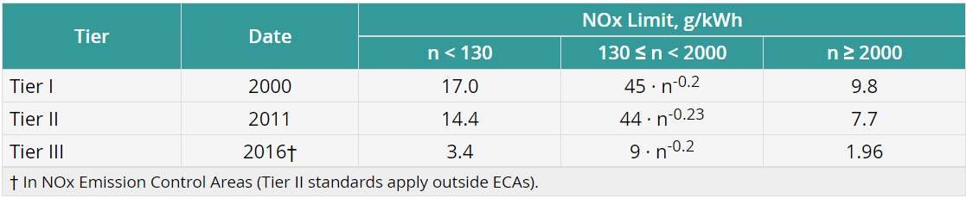
Figure1. MARPOL Annex VI NOx emission limits
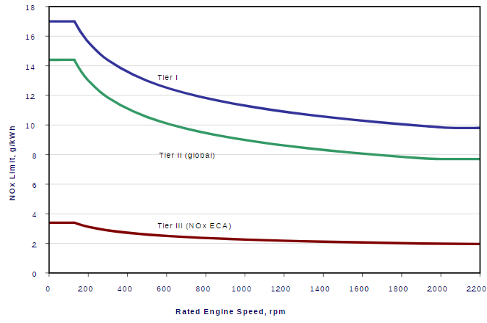
Source: diselnet website

Tier II standards are expected to be met by combustion process optimization. The parameters examined by engine manufacturers include fuel injection timing, pressure, and rate (rate shaping), fuel nozzle flow area, exhaust valve timing, and cylinder compression volume.
Tier III standards are expected to require dedicated NOx emission control technologies such as various forms of water induction into the combustion process (with fuel, scavenging air, or in-cylinder), exhaust gas recirculation, or selective catalytic reduction.
Pre-2000 Engines: Under the 2008 Annex VI amendments, Tier I standards become applicable to existing engines installed on ships built between 1st January 1990 to 31st December 1999, with a displacement ≥ 90 liters per cylinder and rated output ≥ 5000 kW, subject to availability of approved engine upgrade kit.
Testing: Engine emissions are tested on various ISO 8178 cycles (E2, E3 cycles for various types of propulsion engines, D2 for constant speed auxiliary engines, C1 for variable speed and load auxiliary engines).
Addition of not-to-exceed (NTE) testing requirements to the Tier III standards is being debated. NTE limits with a multiplier of 1.5 would be applicable to NOx emissions at any individual load point in the E2/E3 cycle.
Engines are tested using distillate diesel fuels, even though residual fuels are usually used in real life operation.
Further technical details pertaining to NOx emissions, such as emission control methods, are included in the mandatory “NOx Technical Code”, which has been adopted under the cover of “Resolution 2”.
And NOX cause problems in marine engine as the following:
- High Cylinder Temperature and Pressure during combustion process
- Heavy Load on the engine or engine unit.
- Improper air and fuel ratio for combustion.
- High Temperature of intake or scavenge air inside the cylinder.
- Overheated cylinder jacket due to poor heat transfer by jacket cooler.
- Jacket water temperature is on the higher side.
- Bad quality of fuel used for engine.
D- SOX emission standards (SOX) Annex VI regulations include caps on sulfur content of fuel oil as a measure to control SOx emissions and, indirectly, PM emissions (there are no explicit PM emission limits). Special fuel quality provisions exist for SOx Emission Control Areas (SOx ECA or SECA). The sulfur limits and implementation dates are listed in Table 6 and illustrated in Figure 3.

Table 6. MARPOL Annex VI fuel sulfur limits
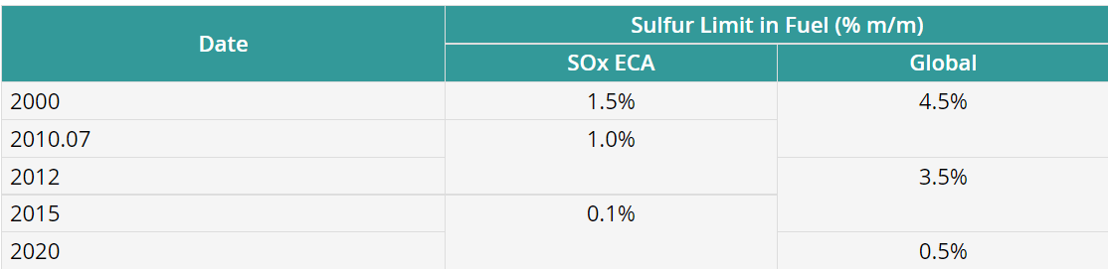

Figure 2. MARPOL Annex VI fuel sulfur limits
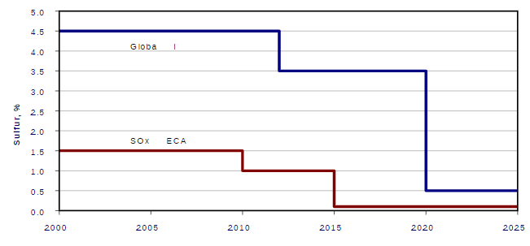

Heavy fuel oil (HFO) is allowed provided it meets the applicable sulfur limit (i.e., there is no mandate to use distillate fuels).
Alternative measures are also allowed (in the SOx ECAs and globally) to reduce sulfur emissions, such as through the use exhaust gas cleaning systems (EGCS), aka scrubbers. For example, in lieu of using the 0.5% S fuel (2020), ships can fit an exhaust gas cleaning system or use any other technological method to limit SOx emissions to ≤ 6 g/kWh (as SO₂).
The resulting reduction in sulphur oxide (SOx) emissions from ships is having major health and environmental benefits for the world, particularly for populations living close to ports and coasts. Sulphur oxides are harmful to human health, causing respiratory, cardiovascular and lung disease. Once released in the atmosphere, SOx can lead to acid rain, which impacts crops, forests and aquatic species and contributes to the acidification of the oceans.

2.7.4 Quantity control
One of the challenges that face bunkering market in Egypt is the quantity of fuel that transferred from bunker ship to other ship. And the methodology of quantity control must be effective to make sure the quantity of received fuel bunk and it could be controlled by the following method:
A-Flow meter readings
Description of monitoring method Flow meters can also be used to figure out a ship's fuel usage. These meters are used to determine how much fuel is flowing via the various pipelines. Fuel flow is frequently measured either directly (by volume, velocity, or mass) or indirectly (by pressure). To catch all of the fuel oil utilised on board, all external flows from all of the ship's storage tanks would have to be monitored. There are many different types of flow metres, including electronic, mechanical, optical, and pressure-based flow metres. The following box depicts the many types of flow metres used to monitor gasoline usage,(Jasper Faber, 2013).
After the flowmeter, some bunker barge flowmeters have a small bleed-off tube that returns the bunkered fuel to the suction side of the barge bunker supply pump. It essentially means that the fuel goes through the flowmeter twice. The by-pass recirculation line may be tiny in diameter, but it can have a significant impact on the amount of gasoline bunkered over the course of the bunkering period,(business, 2015).
Countermeasures: After the barges flowmeter, look for any abnormal lines. As a cross-check, use the ship's flowmeter (if equipped) and examine any substantial variances. Check the flowmeter seal on the bunker barges and ask to view the flowmeter calibration certificate. To assist with the inspection of any questionable lines, consult the bunker barge cargo pipe schematic,(business, 2015).
B-Bunker Delivery Notes
Description of monitoring method
The International Maritime Organization (IMO) has regulations in place (Regulation 18 of MARPOL Annex VI) that require vessels of 400 GT and up, as well as platforms and drilling rigs, to keep a record of the fuel oil they bunker using a bunker delivery note (BDN).
Although the BDN is now used to regulate air pollution, it also carries information that can be used to track fuel consumption over time and so estimate CO2 emissions.
The bunker fuel provider issues the BDN. The following information must be included in the BDN (MEPC.1/Circ.508):
* name and IMO number of receiving ship;
* port;
* date of commencement of delivery;
* name, address and telephone number of marine fuel oil supplier;
* product name(s);
* quantity (metric tons);
* density at 15˚C (kg/m3
* sulphur content (% m/m); and
a declaration signed and approved by the fuel oil supplier's representative stating that the fuel oil supplied complies with MARPOL Annex VI Regulations 14(1) or (4)(a) and Regulation 18(1).
The bunker delivery notes must be retained on board for a minimum of three years following delivery, according to MARPOL Annex VI Regulation 18.
It is important to note that information on the amount of fuel bunkered within a certain time frame is insufficient for determining the amount of fuel used within that time frame because the tanks are unlikely to be empty at the start and conclusion of the period.Thus to establish a periodic fuel consumption, stock-takings at the beginning and at the end of the period are necessary too,(Jasper Faber, 2013).
Measuring twice is one way to alter the amount of fuel oil given. It is accomplished via gravity-fed fuel transfer from one tank to another. One of the initial tank values measured is then gravity-fed to a nearby slack tank, which will be the last to be monitored. This is usually accomplished by moving from an aft gasoline tank to a forward slack tank, with the gauging having begun in the aft tanks. Countermeasure: Before beginning delivery, double-check the first tanks that were measured,(business, 2015).
C-Tank monitoring
Description of monitoring method
A ship's fuel usage can also be determined by monitoring the ship's tanks. On-board ships, fuel tank levels are frequently measured. Tank sounding is another term for this. The depth of the fluid from the surface to the bottom of the tank is thus determined first, followed by the calculation of the equivalent volumetric quantity. To convert tank level to volume, sounding tables are required. This is usually provided in an approved form as part of the ship stability documentation. To determine the appropriate mass, you'll need to know the density of the fuel. This is available through the BDN, however blending on board may provide some challenges. The volume will be affected by the temperature of the fuel (CE Delft, 2009).The fuel tank levels can be measured in a variety of ways, including electronically, mechanically, and manually, as illustrated in the box below,(Jasper Faber, 2013).
Seals on sounding and ullage pipes, according to the delivery barge, cannot be broken. Pretexts such as Customs seals or a seized sounding cock are frequently used to conceal the deception. Flowmeter measurement is usually the sole alternative to gauging the tanks.(business, 2015).
Be aware of air being put into the metre to inflate the displayed measured delivery. The "cappuccino effect" is a term used to describe this phenomenon (see below). Countermeasures include refusing to agree to simply metering fuel oil delivery. If Customs seals are cited, write a complaint letter or comment on the bunker delivery receipt with a counter-signature from the barge master,(business, 2015).
2.8Technical aspect (Single hull barges)
There are international requirements for environmental protection and oil pollution preventing that must be taken in consideration during bunkering to avoid oil spell and pollution for marine environment.
The Reason for the New Rules The fundamental motivation for raising oil barge regulations is to ensure environmental safety. The OPA-90 was motivated by public concern following the enormous Exxon Valdez leak. According to research, double-hulled barges may have a lower negative environmental impact. Double hulls, according to OPA-90, limit the damage experienced by tankers and barges engaged in accidents, and thereby reduce oil spills, (Logs, 2014).
According to a research published in 2011 in the Marine Pollution Bulletin, the double hull design reduces the magnitude of oil spills by 20% in tank barges and 62 percent in tanker ship accidents. The expense of rehabilitation is significant for vessel operations, but "the industry is keen to further improve the safety of tankers," says the report,(Logs, 2014).
It’s essential for vessel operations to adhere to the new rules to avoid costly ramifications. First, there is legal liability to consider. In an oil spill, vessel owners can be liable up to $10 million, and if they are guilty of gross negligence, liability will be unlimited and they will be subject to both civil and criminal sanctions.
Furthermore, inspectors will be waiting at ports to ensure that vessels are not being used for transporting oil after the deadline has passed. After January 1, 2015, if the Coast Guard finds an oil barge or tanker operating with a single hull, the inspectors have the authority to:
- order the vessel to cease operation;
- revoke its certificate; and
- Impose a civil penalty upon the owner or operator.
Staying in Compliance with Regulations
It’s essential to stay in compliance with the federal and international regulations in order to avoid sanctions and penalties, (Logs, 2014).
most of the structure of bunker vessels hull are single hull, which cause a threat to the marine environment and the barges that used in Egyptian port for bunkering process are still single hull that may led to oil spill during damage of hull and marine pollution therefore, the technical specification for barges aren’t competitive for the barges that work in the world ports,(other,2020).

3-Singapore

3.1 Introduction
Between January and April2021, roughly 919 vessels docked in Singapore, consuming nearly 17 million metric tonnes of bunker fuel. Tankers made up the majority of the boats that arrived, accounting for more than 8000 between January and April 2021.Oil tankers dominate Singapore's vessel industry as a crude oil importing country, accounting for almost 6,347 from January to April 2021.Furthermore, with the increased use of natural gas, particularly in the power sector, Singapore is likely to expand LNG imports via marine routes from places such as Africa and Australia. As a result, such a situation would raise LNG tanker demand in the country, thereby supporting market growth throughout the projection period.

3.2 Market overview
During the forecast period of2020-2025, the Singapore bunker fuel market is expected to develop at a CAGR of more than 14%.The country's bunker fuel market is primarily driven by the increasing use of support vessels for offshore oil and gas developments, the implementation of stricter environmental regulations driving demand for cleaner bunker fuels, and the ever-increasing marine transportation of essential commodities. However, the COVID-19 epidemic, which has resulted in a global economic downturn and a decline in maritime imports and exports, is expected to limit the Singapore bunker fuel market's growth in the coming years.
• Due to factors such as the IMO 2020 Regulations, which went into effect on January 1st, 2020, the market for Very Low Sulfur Fuel Oil (VLSFO) is likely to increase significantly during the forecast period.
• Due to IMO 2020 Regulations and a resurgence in maritime traffic, Singapore's bunker fuel market is expected to boom.

3.3 Volume of sales
The chart 2 below illustrates the marine fuel sales from 2014 to 2021 in Singapore.
Marine Fuel Sale 2014-2021, In million metric ton
In 2017, the fuel sales were 50.6 and that was the maximum sales throughout this period.
In 2021, till the end of April-2021 the total sales was 17.1
As we can see from the bar chart .At the period from 2014 to 2021
And In 2014, the fuel sales was 42.4 and then sales increased slightly till the end of 2017
After that, sales went down at the period of 2017 to the end of 2019 but, went up again in 2020.

Chart 2: Marine Fuel Sale 2014-2021
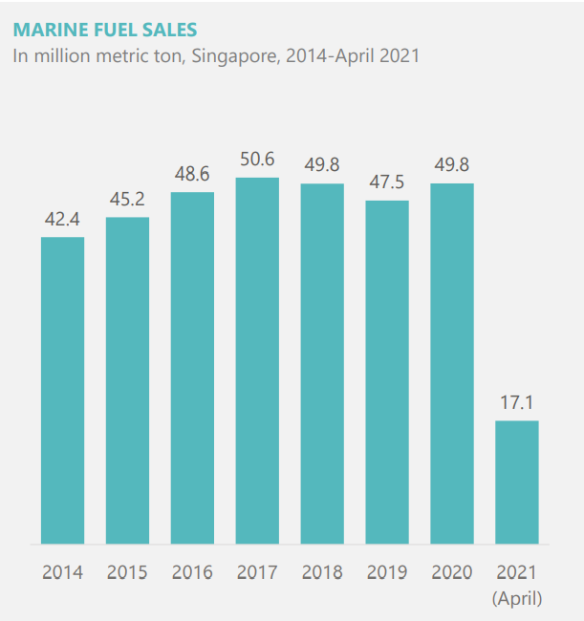

BUNKER FUEL MARKET Size and Demand Forecast in thousand metric ton, Singapore, 2018-2026
Chart 3 illustrates BUNKER FUEL MARKET Size and Demand Forecast in in million metric ton Singapore at the period from 2018 to 2026,
As we can see from the bar chart3:
In 2018, the demand forecasting was the minimum and after that, the demand foresting gradually rise till the end of 2026. That’s mean that the maximum demand forecasting will be in 2026.

Chart 3: Market Size and Demand Forecast 2018-2026
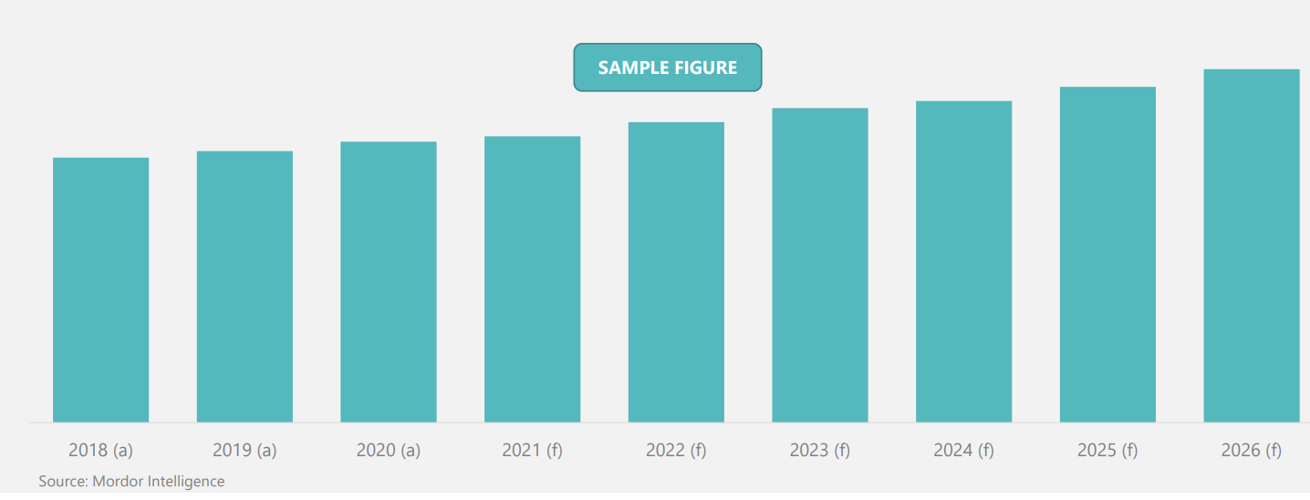

3.4 The Reasons of success

The reason of success are divided into two points

3.4.1 The effective vital role of Port State Control
The organized of service (the state) has vital role in issuing instruction and regulation that must be followed by bunker companies ,The good control and observation for service suppliers and Preserving the marine environment.
Control measures by port States which should take appropriate measures to ensure compliance with the 0.50% of sulphur limit under MARPOL Annex VI, in line with the regulation 10 of MARPOL Annex VI and the 2019 Guidelines for port State control under MARPOL Annex VI (resolution MEPC.321(74)) (2019 PSC Guidelines). Specifically, the port State should conduct initial inspections based on documents and other possible materials, including remote sensing and portable devices. Given "clear grounds" to conduct a more detailed inspection, the port State may conduct sample analysis and other detailed inspections to verify compliance to the regulation, as appropriate.

3.4.2 Bunkering Services Providers in Singapore
Singapore, being the world's largest bunkering port, works hard to maintain its reputation as a trustworthy and dependable bunkering hub. The Maritime and Port Authority of Singapore (MPA), as the industry's regulator and promoter, regularly collaborates with the industry and stakeholders to improve Singapore's bunkering standards and services. Singapore has taken initiatives over the years to improve its bunkering standards and services so that they remain relevant in the industry. The MPA requires all bunker suppliers, bunker craft operators, bunker surveyors, and bunker surveying firms operating in Singapore's port to be licensed. The MPA has a zero-tolerance policy for bunkering fraud and will not hesitate to prosecute any unlicensed firm operating in the Port of Singapore.

3.5 IMO 2020 as a new challenge
Global limit on sulphur in ships' fuel oil reduced from 01 January 2020
A global regulation that will substantially reduce harmful sulphur oxide (SOx) emissions from ships comes into effect from 1 January 2020, bringing significant benefits for both human health and the environment.
From 1 January 2020 the global upper limit on the sulphur content of ships' fuel oil will be reduced to 0.50% (from 3.50%). Known as "IMO 2020", the reduced limit is mandatory for all ships operating outside certain designated Emission Control Areas*, where the limit is already 0.10%.
The new limit will mean a 77% drop in overall SOx emissions from ships, equivalent to an annual reduction of approximately 8.5 million metric tonnes of SOx. Particulate matter - tiny harmful particles which form when fuel is burnt – will also be reduced, (IMO, 2019)

3.6 A Singapore Guide For Bunkering Industry
It aims to preserve the marine environment by minimizing pollution of the oceans and seas. MARPOL Annex VI was adopted in 1997 and took effect in 2005 to address air pollution from shipping. In October 2008, MARPOL Annex VI was amended to reduce the sulphur content limit of marine fuels. Come 1 January 2020, the range of compliant fuel that will be available in Singapore includes:
• Marine Gas Oil (MGO)
• Low Sulphur Fuel Oil (LSFO)
• Liquefied Natural Gas (LNG)
• High Sulphur Fuel Oil (HSFO) - for ships fitted with scrubber The sulphur content of any fuel oil used on board ships shall not exceed the following limits:
4.50%m/m prior to 1 January 2012;
3.50%m/m on and after 1 January 2012; and
0.50%m/m on and after 1 January 2020, (IBIA, 2020).

3.7 MPA’s efforts towards IMO 2020

3.7.1 Fuel oil availability:

MPA has been working closely with all licensed bunker suppliers to ensure that they would be able to supply 0.50%m/m sulphur content fuel (“compliant fuel”) come 2020. In this regard, MPA has published an information sheet on its corporate website. This information sheet aims to promote greater transparency and certainty to the shipping community on Singapore’s readiness in complying with the 0.50% sulphur cap limit regulation. The information sheet provides a list of licensed bunker suppliers and the types of compliant fuels available in Singapore, which include Marine Gas Oil, Low Sulphur Fuel Oil, Ultra Low Sulphur Fuel Oil and High Sulphur Fuel Oil, (IBIA, 2020).

3.7.2 Amendments to bunker delivery note
As the industry prepares for the IMO 2020 rule, changes to the Bunker Delivery Note (BDN) for Marine Fuel Oil (MFO) deliveries went into effect on January 1, 2019. The fuel oil supplier should submit BDN, as required by MARPOL Annex VI regulation 18. The requirements of appendix V of MARPOL Annex VI should be included in the BDN text. Fuel oil suppliers should also follow the current versions of national standards such as SS 524 - Singapore Standard Specification for Quality Management for Bunker Supply Chain, SS 600 - Singapore Standard Code of Practice for Bunkering by Bunker Tankers, and TR 48 – Technical Reference for Bunker Mass Flow Metering when delivering bunkers in Singapore.
MPA has the authority to take regulatory action against fuel oil suppliers that do not follow the current bunkering regulations and licensing requirements. The bunker provider must indicate the necessary points in the following cases by 1 January 2020:
1- On and after January 1, 2020, the sulphur content of fuel oil used on board ship must not exceed 0.50 percent m/m for bunker delivery.
2- After 1 January 2015, the sulphur content of fuel oil used on board ships for bunker deliveries to ships operating within an emission control area must not exceed 0.10 percent m/m.
3- For bunker deliveries if the sulphur content of the fuel oil used on board exceeds 0.50 percent m/m and is in compliance with Regulation 4 or 3.2 of MARPOL Annex VI, (IBIA, 2020).

3.7.3 Bunker transport, storage and transfer
During shipping, storage, and transfer, the quality of bunker fuel or blended components may deteriorate. The following steps should be followed by the bunker provider to assure bunker quality: Prior to loading into the cargo tank, ensure that items from different shore tanks have the same grade and quality certificate. Before placing a fresh cargo into a cargo tank, make sure it's empty.
Ensure that the product is stored and handled properly on board. This includes keeping fuels at the proper temperature and avoiding outside water from entering the tank.,(IBIA, 2020).

3.7.4 Mass Flow Meter for Bunkering
All Marine Fuel Oil (MFO) bunker deliveries in the Port of Singapore must use the MPA-approved MFM system starting January 1, 2017. The Bunker Delivery Note shall state the delivered quantity of MFO based on the bunker tanker's MFM system as witnessed by the cargo officer, chief engineer, and bunker surveyor (if engaged).

3.7.5 Bunkering Standards
Singapore, as the world's largest bunkering port, has adopted bunkering standards that encompass documentation, equipment, procedures, and the quality of bunker fuel provided, among other things. MPA examines these criteria on a regular basis to ensure that the most strict standards are followed in the Port of Singapore,(IBIA, 2020).

Results and Recommendations:

Recommendations:
1- Give the priority to the efficiency of storage warehouses to promote the activity of bunkering, and increase their capacity Storage to accommodate large quantities of bunker. And the importance of having all the services and capabilities (such as: heating and mixing processes) required for bunker fuel while stored.
2- Paying attention to barges in terms of reducing the cost of the service provided, and increasing their capabilities in terms of: Storage capacity, preheating and mixing rate to be able to compete with global ports, And to allow transfer bunker fuel for ships in large quantities in a short time, which contributes to reducing the time of voyage for ships.
3- Pay attention for monitoring and follow-up procedures in different sites to protect the work environment and the surrounding environment from pollution, and pay attention to efficiency and making sure that barges are compliant with the international maritime organization (IMO) regulations. Therefore, it will have a Significant and positive impact on the implementation of many marine bunkering operations activity in ports.
4- Pay attention for modification on the national laws that obstacle the bunkering market in Egypt and giving more facilities for attracts investments in this activity.
5- Pay attention for shipbuilding of bunkering ships compliance with the new requirements of IMO to help in developing the bunkering activity in Egypt.

Suggested Researches:

1-To complement the role of scientific research and its importance in finding and providing solutions to the problems of societies In order to develop it and achieve its development, scientific research were suggested that aimed to make the Maximum benefit from the unique strategic location that characterizes Egypt.
2- Expanding in researches that aim at develop seaports and develop logistics services to be compliance with international ports so that its main objective is to provide many Logistics services for passing ships, and the port authorities’ role is not limited to collecting passing fees only.
3- Studying ways to encourage local and foreign investors to invest in developing
Ship bunkering stations in Egyptian ports.
4- A feasibility study for the establishment of natural gas-powered ship bunkering stations to comply with the current global trend in light of the existing of the new environmental requirements so, it achieves leadership for the Egyptian ports
And maximizing the economic benefits by converting ship to alternate fuel (LNG) with also, in the same time with the discoveries of natural gas is growing.

References:
References in English:
(EPA), U. S. (n.d.). Marpol Annex VI and the act to prevent pollution from ships (APPS).

Policy in Action. Dubai.(2016). - United Arab emirates: federal Competitiveness and Statistics Authority.

The 8th Gulf Intelligence Energy Markets Forum 2018. (2018). The 8th Gulf Intelligence Energy Markets Forum 2018. FUJAIRAH: Consultancy Intelligence Publishing.

Cutting Sulpher Oxide Emission.(2020). IMO.

Navigation Statistics.(2020). Suez Canal Authority .

Keppel Delivers FueLNG Bellina, Singapore’s First LNG Bunkering Vessel. (2021). Marine Link.
Procedure for portstate control.(2021). IMO.

Anish. (2021). A Guide To Marine Gas Oil and LSFO Used On Ships. Marine Insight.

Anish. (2021). Bunkering is Dangerous: Procedure for Bunkering Operation on a Ship. Marine Insight.

business, s. (2015). Avoiding bunker fuel quantity and quality claims- Guideline for ship.

diselnet. (n.d.). IMO Marine Engine Regulations.

Heather Thomson, J. J. (2015). Natural gas as a marine fuel. Elsevier.
IBIA, M. a. (2020). A Guide For Bunkering Industry .

IMO. (2019). IMO 2020 - cleaner shipping for cleaner air. IMO.

Ingpen, B. (2015). Bunkering (refuelling). Mritime South Studies Africa.

Insights, S. G. (n.d.).

Jasper Faber, D. N. (2013). Monitoring of bunker fuel.

Khasawneh, R. (2021). Singapore Ramping Up LNG Bunkering Capacity. Marine Link.

Logs, M. V. (2014). All Single Hull Oil Barges Must Be Ousted by 2015. MET Staff |.

MDLALOSE, S. (2019). DETERMINANTS OF A COMPETITIVE BUNKERING SERVICE: A SOUTH AFRICAN MODEL . South Africa: NELSON MANDELA UNIVERSITY.

MEPC.320(74), R. (2019). GUIDELINES FOR CONSISTENT IMPLEMENTATION OF THE 0.50% SULPHUR LIMIT UNDER MARPOL ANNEX VI. IMO.
Network, M. N. (2021). FAQs: Sulphur Limits In Emission Control Areas From 1st January 2015. Marine Insight.

Osama I. Abulhassan, T. A. (2020). THE IMPACT OF LOGISTIC AND ENVIRONMENTAL FACTORS ON ACTIVITY OF SUPPLYING SHIPS WITH FUEL (BUNKERING) IN THE SUEZ CANAL REGION.

Raptis, S. (2016). Natural gas in ships. Brussels: Transport & Environment.

Rasoul, S. M. (2022). THE EFFECT OF USING THE ADDED VALUE FROM THE POINT OF VIEW OF FREIGHT STATION TO OPERATE THE DRY PORTS. Alexandria: AAST.

Ratner, M. (2011). Implications of Egypt’s Turmoil on Global Oil . Washentogn: Cogress Press.

Saadi, D. E. (2019). Trading up: Fujairah’s plan for growth. Fujairah.

SCA. (2019). New Suez Canal.

Yasser B. A. Farag, M. S. (2020). A Review of Egypt’s Transition to LNG; Challanges and Recommendation . Research Gate.
Žaglinskis, J., Rapalis, P., & Lazareva, N. (2017, November 13). An overview of Natural Gas Use in ships. Necessity and Engine Supply.

Reference in Arabic
Ahmed Badwy.(2020).after the resolutions of IMO were entered into forces.forcasting with increasing of maritime transport feeses.Almal Journal.

Osama Ibrahim Abulhassan and others. (2020). The effect of logistical and environmental factors on the activity of ships bunkering. Journal of Environmental Sciences.

Decision No. 488 of 2015. Al-Waqa’a Al-Masryah-205 (continued) on September 7,2015.(2015).

Resolution No. 800 of 2016. Al-Waqa’a Al-Masryah – No. 282 continued (B) on December 15, 2016.(2016).

Rania Mohammed Ahmed Al Sheikh. (2018). Factors affecting the establishment of a logistics center in the Suez Canal region, compared to Singapore, Panama and Dubai. Scientific Journal of Commercial and Environmental Studies, Suez Canal University, Faculty of Commerce.

Rabab Fathi Abdulaziz Najm. (2005). The impact of globalization on the shipping industry in the Arab countries. Cairo: Master's Thesis, Faculty of Commerce, Ain Shams University.
Resolution No. 20 of 1976 regarding the General Petroleum Corporation. (1976). The Official Gazette of the Presidency of the Republic.

Mohamed Nasr El-Din Ahmed. (2018). The relationship between the Suez Canal and the logistics centers. Scientific journal for scientific and environmental studies
in Suez Canal University at the Faculty of Commerce.

Yousra Mohamed Hassan El Gohary. (2018). Effects of enhancing the competitiveness of Egyptian commercial ports on Egypt's foreign trade. Cairo: Rectory, Faculty of Commerce, Department of Economics, Ain Shams University.

