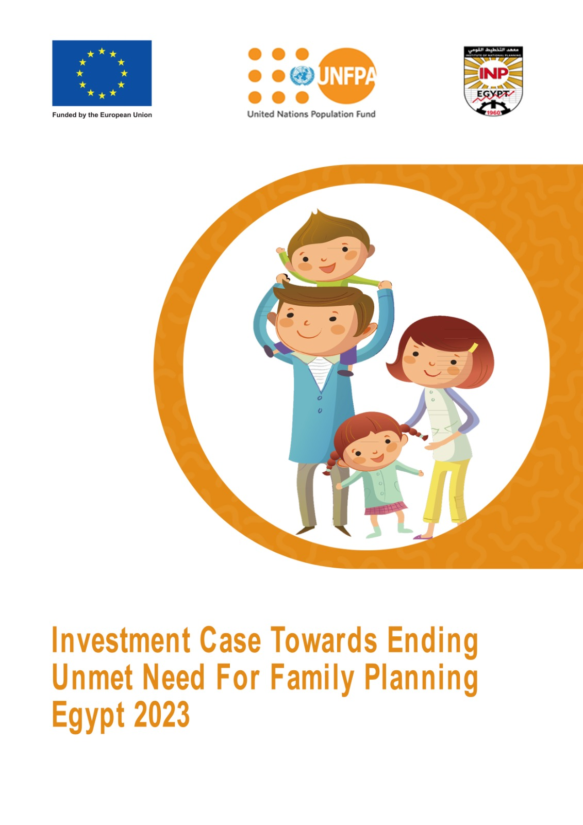

Executive Summary

Background
Egypt faces the persistent challenge of unmet need for family planning (FP) that stands at 13.8%, despite progress in reducing fertility rates that reaches 2.85 in 2021. Gaps between women’s fertility preferences and actual contraceptive use exist due to barriers such as limited access to information and resources, inadequate service quality, opposition from partners and families, and cultural views against contraceptives.
Addressing this issue is crucial for women’s reproductive and maternal health, child health, gender equity, socioeconomic development, and achieving Egypt's demographic goals. Population dynamics, with a large youth population and ongoing growth, place additional strain on public resources and services. Strategic investments in family planning are essential to foster sustainable development and build a resilient future.

Current Situation
Egypt employs a mixed public-private FP system with the Ministry of Health and Population (MOHP) playing a leading role. Initiatives with non-governmental organizations under the leadership of the Ministry of Social Solidarity and the National Project for the Development of Egyptian Families support awareness and service provision. Donor assistance also plays a role, providing support to various national entities. Despite these efforts, Egypt faces challenges in health financing. Out-of-pocket (OOP) spending constitutes a large portion of total healthcare expenditure, with only about a third covered by the government. While efforts are underway to increase public health funding and to meet the constitutional obligations of a health budget of 3% of GDP by 2030, the sector currently falls short of the 15% GDP target set by the Abuja Declaration. Challenges also include:
- Regional Disparities: Unmet need is higher in rural Upper Egypt.
- Service Quality: Concerns about side effects and discontinuation rates highlight the need for improved counselling and follow-up.
- Socio-Cultural Barriers: Norms and beliefs can influence FP decisions.
- Health Financing: Egypt's system relies heavily on OOP spending (60%). There's an ongoing effort to boost public health expenditure to reduce the financial burden on citizens.

Purpose of Investment Case
This investment case serves as instrumental tool to demonstrate the transformative potential of addressing unmet need for FP through strategic investments. It underscores the economic and social advantages of addressing this issue, informs decision-making and ensures that investments are channeled effectively and efficiently toward achieving lasting positive outcomes. They serve as catalysts for increased public investment and the promotion of private financing partnerships, fostering a collaborative and comprehensive approach to achieving family planning objectives. Key potential benefits include:
- Health Impacts: Reduced maternal mortality, improved child health, lowered unintended pregnancies, and reduced unsafe abortions.
- Economic & Social Progress: Enhanced educational and economic opportunities for women, increased household savings, and a positive influence on GDP growth.
- Demographic resilience: Stabilized population growth, easing adaptation of systems and harnessing opportunities.
- Cost-Effectiveness: Significant returns on investment realized by decreasing long-term public expenditures associated with unintended pregnancies, healthcare, and social support.

Methodology
1. Collaborative Approach
A reference group of experts from various pertinent government entities, alongside the UNFPA Egypt country office and the UNFPA HQs was established. The primary objective of this distinguished group was to ensure the robust validation of the data's integrity and the selected scenarios, underscoring the commitment to the reliability and accuracy of the study's findings.
2. Modelling and Data
- Tools: The Impact40 toolkit (UNFPA, Avenir Health, et al.) was used, including the FamPlan module for calculating contraceptive prevalence rate (CPR), modern contraceptive prevalence rate, mCPR), total fertility rate (TFR), and unmet need for FP, and the Lives Saved Tool (LiST) Costing module to estimate costs of addressing unmet needs for FP.
- Data Sources:
- Family Planning: Egyptian Family Health Survey 2021 (EFHS)
- Demographics: Central Agency for Public Mobilization and Statistics 2021-2022
- Costs: Ministry of Health and Population
- Regional Estimates were applied when national data gaps exist, the Spectrum tool was used to inform country-level estimates.
3. Scenarios
The analysis focuses on increasing the mCPR to address unmet need for FP. Three scenarios in addition to the status quo were modeled. These scenarios showcase varying CPR and mCPR levels, detailing the resulting health outcomes, reductions in fertility rates, and the necessary resources to raise FP interventions to achieve these diverse levels of success.
- Baseline/Status quo: CPR remains at 66.4%.
- Scenario 1: CPR increases to 70% by 2030.
- Scenario 2: CPR reaches 75% by 2030 (aligning with SDGs and the National Population and Development Strategy 2023-2030).
- Scenario 3: CPR reaches 80.2% by 2030.
4. Contraceptive Method Mix
The 2021 EFHS was used to provide the baseline data on contraceptive method usage. The Experts Group validated projections that anticipate a shift in family planning preferences towards greater reliance on modern methods over time: Modern Methods on the Rise: Increased use of implants and IUDs is expected.
- Traditional Methods Declining: Withdrawal, periodic abstinence, and other traditional methods are projected to decrease significantly or disappear by 2030.
- Mixed Trends: Injectable use and pill use are expected to slightly decrease, as well as condom and female sterilization.
5. Definition of Unmet Need
The definition aligns with WHO/EFHS criteria and focuses on women of childbearing age (15-49):
- Spacing: At risk of pregnancy, not using FP, and wanting to delay the next birth or uncertain about timing.
- Limitation: At risk of pregnancy, not using FP, and wanting no more children.

Results and impact of ending unmet need
- Reduction in Unmet Need
All scenarios project a decrease in unmet family planning need from 2023-2030 with the anticipated increased contraceptive use:
- Scenario 1: Unmet need declines to 11.6% by 2030
- Scenario 2: Unmet need drops to 8.6% by 2030
- Scenario 3: Unmet need reaches 5.7% by 2030
- Impacts on Health Outcomes
Increased modern contraceptive use is projected to reduce the number of unintended pregnancies and unsafe abortions. Between 2023 and 2030, the total number of unintended pregnancies is 11.5 million and the unsafe abortions is 5.7 million in the status quo. Scaling up the contraceptive use will lead to averting large numbers of unintended pregnancies and unsafe abortions as per below chart.

Cost of Ending the Unmet Need for Family Planning
Cost Categories: Interventions to address unmet need for FP have costs in four main areas: Drugs and Supplies, Labor, Capital and other Recurring Costs.
The total FP Intervention Costs include all costs associated with family planning. Costs increase as contraceptive prevalence targets rise. This means higher targets require more resources for services and supplies as per below chart:

Incremental costs show the financial impact of scaling up family planning to meet unmet needs. These are additional costs required to achieve higher contraceptive prevalence rates, compared to the baseline/status quo. Labor is the largest incremental cost driver; it increases significantly across all scenarios as targets for contraceptive use rise.

Incremental Costs by Method
- Labor Dominates: Labor costs are the highest for all contraceptive methods across scenarios.
- Pill Costs Significant: Due to frequent use, the total cost of pills remains high, even if usage decline.
- IUD Costs also Rise: Costs increase significantly as IUD use becomes more prevalent in higher prevalence scenarios

Investment required and financing gap
The lack of comprehensive national data pertaining to the cost of FP methods and the actual expenditures incurred in FP programs poses a limitation. The investment case relied on unit costs provided by MOHP for selected methods, serving as the basis to assess the funding requirements to achieve each of the projection scenarios. To determine the funding gap to reduce the unmet needs of family planning, the investment case first uses total FP intervention costs. Secondly, the investment case employed the percentage of the family planning budget allocated to programs during the fiscal year 2023/2024, amounting to 0.0076% of the national budget of Egypt. The investment case assumes an increase of the allocated budget assigned by the same percentages, mirroring the annual increase in incremental costs.

Key Messages
- The investment case advocates for increased investment in family planning in Egypt, emphasizing the ambitious goal of eliminating unmet needs.
- The total cost between 2023 to 2030 of FP related with the status quo amounts to EGP 10.3 billion. For Egypt to reduce the unmet need by 2030, aligning with the SDG target and the updated Population Strategy (scenario2) an additional investment of EGP 825 million is needed over the coming seven years, bringing the total investment to EGP11.1 billion to achieve the 75% CPR.
- Compared to the status quo, scenario 2 (75% CPR by 2030) could prevent around:
  - 1.5 million unintended pregnancies.
  - 733k unsafe abortions.
- Funding is estimated to fall short by an average of 70% across all scenarios (2023-2030).
- Closing the gap will require exploring alternative funding sources like integrated approach, innovative financing tools, donors and partnerships.
- Reduced unmet needs by 2030 contribute to achieving several SDGs:
  - SDG Goal 3 (Good Health and Well-being): Reduce maternal mortality, unintended pregnancies, and unsafe abortions.

Financing gap for family planning to end unmet need, 2023-2030
(in billion EGP)
 | Scenario 1 (2030 Target: 70% CPR) | Scenario 2 (2030 Target: 75% CPR) | Scenario 3 (2030 Target: 80.2% CPR)
Total estimate funding required, for total interventions 2023-2030 (A) | 10.6 | 11.1 | 11.6
Projected public budget allocation for family planning (B) | 3.24 | 3.3 | 3.6
Financing Gap (C) = [(A) – (B)] | 7.36 | 7.8 | 8
Financing Gap = (C)/(A) (%) | 69.43% | 70.27% | 68.96%

  - SDG Goal 5 (Gender Equality): Empower women by giving them control over their reproductive health.
  - SDG Goal 1 (No Poverty): Improve economic well-being by enabling smaller families and increasing female workforce participation.
- Family planning stands as a pivotal factor with the potential to significantly influence health and broader development outcomes. This includes a reduction in unintended pregnancies, unsafe abortions and maternal deaths.

Recommendations and the way forward
- Strategic implementation and capacity building: it is of interest to develop and implement strategic initiatives to enhance the capacity of healthcare providers to deliver a quality method mix. There is a value added in integrating comprehensive family planning training programs within the broader healthcare framework to ensure sustained impact.
- Data enhancement for informed decision-making: Investing in systems for improved data generation to facilitate evidence-based decision-making for policymakers and establish robust monitoring and evaluation mechanisms to track the progress of family planning programs and their impact on health outcomes.
- Financial commitment and resource allocation: Advocacy efforts to increase financial commitment to family planning interventions, emphasizing addressing unmet needs in Egypt requires work towards securing funding from diverse resources including international partners.
- Continued research and adaptation: Encourage further research by implementing investment cases on reducing maternal mortality and gender-based violence including child marriage and female genital mutilation. And adapting the implementation plan based on emerging research findings, ensuring that interventions remain responsive to evolving needs and challenges.
- Collaborative partnerships: Foster collaboration between government entities, non-governmental organizations, international organizations, and the private sector to leverage collective expertise and resources.

By adopting these recommendations, Egypt can further drive forward its family planning agenda, fostering a future marked by improved health outcomes, gender equality, and societal resilience. Family planning could be seen as a cornerstone for broader public health and development objectives, setting the stage for a healthier, more equitable, and sustainable future for the country.



You can review the full Investment Case through this QR code

