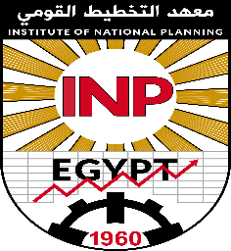
Institute of National
Planning

Master Thesis
The Impact of Education and Training Policies On The Labor Market In Egypt During The Period 2000-2012

Prepared by
Aya Fawzy Kamel Rizk

Supervised by
Prof. Sayed Mohamed Abdelmaksoud

Professor of Regional Development
At The Institute of National Planning

To Get Master Degree
At The Planning and Development

2019
Institute of National
Planning

Master Thesis
The Impact of Education and Training Policies On The Labor Market In Egypt During The Period 2000-2012

Prepared by
Aya Fawzy Kamel Rizk

Supervised by
Prof. Sayed Mohamed Abdelmaksoud

Professor of Regional Development
At The Institute of National Planning

To Get Master Degree
At The Planning and Development

2019

