
جمهورية مصر العربية
معهد التخطيط القومي

Achieving Health Sustainability for Citizens based on Blockchain Technology for
Universal Healthcare Insurance (UHI)

تحقيق الإستدامة الصحية للمواطنين على أساس تكنولوجيا سلاسل السجلات للتأمين الصحي الشامل

Hebat Allah Mohamedd Aboraia El-Kholy

Supervisor
Prof. Amani Helmi El Rayes
To complete the requirements for obtaining a professional master's degree "planning for sustainable development"

2020

Contents
Abstract 2
Introduction 5
1. Literature Review 7
2. Secured Smart Healthcare System (S2HS) 9
3. Blockchain 11
3.1. Blockchain Applications 12
3.2. Blockchain Technology 12
3.3. Blockchain as a Platform 13
4. Blockchain in Healthcare 15
4.1. Blockchain and IOT in Healthcare 16
4.2. Interoperability (Data Exchange) 17
4.3. Application of Blockchain in Magnetic Resonance Images(MRI) 19
4.4. Enhancing Privacy for Patients Data 22
4.5. Benefits of blockchain in the healthcare 22
5. Digital Transformation for Universal Health Insurance (UHI) in Egypt 24
5.1. UHI as a HUB for Beneficiary Operations 26
5.2. Patient Journey 29
5.3. UHI program architecture 29
5.4. Healthcare Data Exchange Benefits 30
Conclusion and Future Work for UHI in Egypt 31
References 34

Abstract
Nowadays, Blockchain technology is considered as one of the most important technologies in the world. Multiple industries are adopting the blockchain technology to innovate the way they work. One of the industries that are looking to adopt the blockchain is the healthcare industry )Healthcare services under umbrella called Universal Health Insurance (UHI)).
In fact, the protection of the private information stored in hospital database is a critical issue. In this paper we propose a method aimed to protect information exchanged in hospital networks, with particular regard to radiology images, lab results, a full patients' history focusing on magnetic resonance images (MRIs). As required from blockchain technology, each host network must validate the transiting data network: we exploit formal equivalence checking to perform this validation, by modeling magnetic resonance images in terms of automata by exploiting radiomic features.
The universal health insurance services are provided to the beneficiaries, who are currently estimated at more than 550 thousand beneficiaries through the system in PortSaid Governorate, and all patients receive their medicines regularly, and the rest of the beneficiaries are being registered.
Whereas, the Universal Health Insurance System Law (Law No. 2 of 2018) covers all citizens residing within the country, and it can be extended optional for citizens residing outside the country, and obliges the state to provide services (public health, preventive services, ambulatory services, family planning, and health services To cover all kinds of disasters, free epidemics, and work injuries)
As the system is working to link the users to the units with its address, an operation room and an electronic sorting facility have been established through which to follow the most important basic data for the users and to detect new Corona virus "COVID-19".
Where a medical team from the largest consultants and doctors in the health care authority in PortSaid, sort these electronic forms, and evaluate the patient's health status, through the answers received to the questionnaire questions, which include questions about the patient's data "name, type, phone, age, national number, address of beneficiary in PortSaid, "in addition to assessing the patient's health condition from his medical history along with the initial procedures of having " high fever, cough, diarrhea, vomiting, difficulty breathing, or any other symptoms he mentions", along with questions about contact with a positive condition For the virus or not, or to travel inside or outside the country during the past 14 days. These are the data that will give preliminary indications of infection with Corona virus, stressing that the cases that will be suspected of infection will communicate with it and sign a comprehensive and accurate examination.
Through these data, a connection is made with the database of the beneficiaries and all the surrounding families who are likely to be in contact or contempt. Therefore, the isolation was applied immediately in any case with the surrounding families, which led to the success of zero corona virus between the medical team in PortSaid in May 2020 and gradually to maintain the families in PortSaid.

Keyword:
Blockchain, Coronavirus disease (COVID-19) ,Healthcare, Internet of Things, Interoperability, Electronic medical records, Patient Journey, Smart healthcare system, Universal Health Insurance.

الملخص
تعتبر تقنية سلاسل السجلات (البلوكتشين) حالياً واحدة من أهم التقنيات في العالم. حيث تعتمد الكثير من الصناعات على هذه التقنية لتساعدها في الابتكار في طريقة عملها. واحده من هذه الصناعات التى تطلع إلى إعتماد سلاسل السجلات هي صناعة الرعاية الصحية (خدمات الرعاية الصحية تحت مسمى التأمين الصحى الشامل).
في الواقع، فإن حماية المعلومات الخاصة المخزنة في قاعدة بيانات المستشفيات هي قضية حرجة. في هذه الورقة البحثية تم إقتراح طريقة تهدف إلى حماية المعلومات المتبادلة في شبكات المستشفيات مع إعطاء إهتمام خاص لصور الأشعة ونتائج المختبر وتاريخ المرضى الكامل.
وسوف نستخدم سلاسل السجلات للتحقق من صحة شبكة البيانات العابرة قبل عملية القبول من الشبكة المضيفة. وسوف نستخدم تأكيد التكافؤ الرسمي لأداء هذا التحقق، وذلك من خلال نمذجة صور الرنين المغناطيسي من حيث الأتمتة بإستخدام الميزات الإشعاعية. وقد أظهرت نتائج إستخدام هذه الطريقة أنها ساعدت فى تقديم خدمات التأمين الصحى الشامل للمنتفعين والذى يقدر عددهم حاليا بأكثر من ٥٥٠ ألف منتفع من خلال المنظومة فى محافظة بورسعيد وجميع المرضى يحصلون على أدويتهم بصفة منتظمة، وجارى الإستمرار فى تسجيل باقى المنتفعين .
وحيث أن قانون نظام التأمين الصحي الشامل (القانون رقم 2 لسنة 2018)، يغطى إلزاميا جميع المواطنين المقيمين داخل البلاد، ويمكن مده إختياريًا للمواطنين المقيمين خارج البلاد، ويُلزِّم الدولة بتقديم خدمات (الصحة العامة، والخدمات الوقائية، والخدمات الإسعافية، وتنظيم الأسرة، والخدمات الصحية لتغطية الكوراث بكافة أنواعها والأوبئة بالمجان، وإصابات العمل)
وحيث أن المنظومة تعمل على ربط المنتفعين بالوحدات بالعنوان الخاص بهم فتم تأسيس غرفة عمليات وفرز إلكترونى يتم من خلالها متابعة لأهم البيانات الأساسية للمنتفعين والكشف عن إصابات كورونا المستجد "كوفيد-19".
حيث يقوم فريق طبي من أكبر الإستشاريين والأطباء بهيئة الرعاية الصحية ببورسعيد، بفرز هذه الإستمارات الإلكترونية، وتقييم الحالة الصحية للمريض، من خلال الإجابات الواردة على أسئلة الاستمارة، والتي تشمل بيانات المريض "الاسم، النوع، التليفون، العمر، الرقم القومي، العنوان التابع له ببورسعيد"، بالإضافة إلى تقييم الحالة الصحية للمريض من التاريخ الطبى له بجانب الأجراءات الأولية من وجود "ارتفاع في درجة الحرارة، كحة، إسهال، قيء، صعوبة في التنفس، أو أي أعراض أخرى يذكرها"، إلى جانب أسئلة عن المخالطة لحالة إيجابية للفيروس أم لا، أو القيام بالسفر داخل أو خارج البلاد خلال الـ14 يوما الماضيين. وهي البيانات التي من شأنها إعطاء مؤشرات أولية للإصابة بفيروس كورنا، مؤكدا على أن الحالات التي سيتم الإشتباه في إصابتها سنتواصل معها وتوقيع الكشف الشامل والدقيق عليها.
ويتم من خلال هذه البيانات الربط مع قاعدة البيانات للمنتفعين وكل الأسر المحيطه المحتمل مخالطتهم او الإشتباه فيهم وبالتالى تم تطبيق العزل فوريا على أى حاله مع الأسر المحيطه مما أدى إلى نجاح تسجيل صفر إصابات كورونا بين الفريق الطبي في بورسعيد فى مايو 2020 وبالتدريج على المحافظة.

الكلمات الإفتتاحية:
سلاسل السجلات (البلوكتشين)، فيروس كورنا المستجد(كوفيد-19)، الرعاية الصحية، إنترنت الأشياء، تبادل البيانات، السجلات الطبية الإلكترونية، رحلة المريض، نظام الرعاية الصحية الذكى، التأمين الصحي الشامل.

Introduction
Egypt is witnessing a major change in its modernization. It turns into a digital transformation to better serve its citizens.
At the present time, the political will tends to build an integrated universal health insurance (UHI) solution that guarantees the health and financial sustainability of Egyptian citizens, which leads them to make it obligatory, as well as to be able to create a health map of Egypt while you are fighting incurable diseases, knowing its causes and eliminating them from the start and reducing Chronic diseases risk, by following the history of electronic medical records for patient with all need of interoperability, data exchange , firstly let we know there are primarily seven elements in the healthcare industry, which are the patient at the core, payer, provider, pharma, regulatory body, medical technology, and technology suppliers. Hence we need to exchange these different elements to communicate and exchange information in real-time. This ease of communication and data sharing is driving the whole of the healthcare industry to move from a paper-based system to digitization. Electronic healthcare records (EHR) are a step taken in this direction. Secondly hence we know the healthcare data is confidential by nature, and every step must be taken to thwart any attack on the data. Also, in order for an extensive integrated healthcare system to sustain, it must be both secure and convenient. Blockchain technology provides such a solution by offering a distributed network of nodes, where if one or more nodes are compromised, the integrity of the overall system remains intact.
In healthcare data, exchange security and scalability is a crucial feature that assures effective collaborative treatment and healthcare decisions for patients and society, also Diagnostic accuracy can be improved using data sharing by collective decisions form the group of medico expert beside patient history. The adoption of blockchain technology in healthcare mostly depends on developing the ecosystem involving partners/stakeholders that have to share and exchange healthcare related information. It is quite possible to build confidence among patients, physicians, hospitals, health insurers, and other stakeholders through blockchain based solutions.
the solution proposed that patient will create the first version of his/her information record during his first visit after the registration phase which will then be loaded to blockchain and smart contracts will be deployed to verify the initial version because patients will only be able to create the initial version of information record , and the remainder data will be completed from the other stockholders like national database, collection places , taxes, supportive ministries like ministry of supply, ministry of Solidarity and all other supportive ministries.
On the other hand, let us admit that no one in Egypt knew what is required for universal health insurance before, and therefore like any technological solution, we must implement firstly as a proof of concept (POC) of the supposed system, so PortSaid Governorate considered as POC model for universal health insurance in Egypt and after Ensuring the sustainability and suitability of the proposed system with the Egyptian citizen and financial sustainability in Egypt is then gradually applied according to the plan set for the implementation of universal health insurance in 6 stages starting from PortSaid Governorate and extending to the governorates of the Canal and South Sinai and Luxor to be given a strategic security dimension as well as to cover our people in Upper Egypt and then the planned phases through the governorates of Egypt
Often healthcare enterprises operate as decentralized organizations. Comprised of semi-autonomous provider groups and service locations, these organizations are decentralized in a way that makes it much more difficult to prioritize cyber security investments, establish standards, and enforce compliance. As a result, the entire enterprise may be exposed by its most vulnerable component, with potentially dire consequences.
Blockchain can be utilized in these cases to achieve the secure accessibility and integrity of the healthcare data. In fact, blockchain as a decentralized and distributed technology can play a key role in providing such healthcare services. The concept of blockchain is being well known for its use in bitcoin and crypto currencies. It has got widespread attention from various stakeholders due to its immense business potential and utilization in various applications such as banking, healthcare and supply chain management. Blockchain technology promises to provide immense opportunities in the healthcare sector such as secure data storing and sharing among various stakeholders, nationwide data interoperability and flexible and quick billing and payment modes. From these considerations, in this paper we propose an architecture blockchain based aimed to guarantee the trustworthiness of magnetic resonance images MRIs passing through the hospital network.

Literature Review
The use of blockchain in healthcare services plays a critical role in the current healthcare market. It can result in automated data collection and verification processes, correct and aggregated data from various sources which are immutable, tamper resistant and provide secured data, with reduced probability of cybercrime, more over it also supports distributed data, with redundancy and fault tolerance of the system. The following research papers show the importance of Blockchain in healthcare.

In (Mashatan, A. et all, 2020) a discussion on how the two key technologies (blockchain and IoT), especially blockchain will improve the healthcare industry. They show that using these technologies will improve processing efficiency. Also sharing electronic health records can help in improving diagnosis accuracy, privacy and security preservation are imperative, and by using IoT "network of IoT devices", exchange involves sensitive medical data, patient monitoring has to be totally secured against privacy risks and attacks, avoiding delays in treatment progress and emergency treatments using medical data security and confidentiality violations.
Implementing healthcare services based on blockchain technology could improve information security management, healthcare data could be analyzed and communicated while preserving the privacy and security of the data.

Fakhri Alam Khan, and others (Khan, F. et all, 2020) show that Blockchain technology considered high priority for different types of stakeholders due to its stable implementation in the field of digital transformation. They also present different uses of blockchain technology, e.g. healthcare, automation industry, energy sector, security and authentication in smart grids.
They explained a state-of-the-artwork in blockchain’s non-financial applications like Healthcare in which contribution of four-layered custom blockchain models related to precision medicine and the clinical trial was notable. Moreover, a mobile app model called HDG for the automation of medical records without compromising privacy was also a prominent contribution.
Prateek Pandey, Ratnesh Litoriya (Prateek, P., Ratnesh, L. , 2020) try to define and evaluate the social and technical challenges that will face implementation of a large scale universal healthcare services and suggest a technological solution to serve the society at large. The research considers India’s National Health Policy (2017) initiatives. discussing the challenges faced the implementation of the social and technical schemes and proposing a Blockchain technology-based solution to eliminate the health policy implementation difficulties. The research shows that implementation of healthcare based on blockchain provides the scalability for a large scale , hence they depends on creating a blockchain and found that the system throughput is a function of the number of special nodes called ordering nodes, and a tradeoff is required to balance between time to commit and system’s fault tolerance. They conclude that healthcare systems based on blockchain provides secured and integrated scalable healthcare services that gives the patient high priorities and provides for corruption intolerant and efficient implementation of nationwide health insurance programs.
Sudeep, T. , Karan, P. and Richard, E. (Sudeep, T., et all, 2019) introduce several solutions for improving current limitations in healthcare systems using blockchain technology, including frameworks and tools to measure the performance of such systems, e.g., Hyperledger Fabric, Composer, Docker Container, Hyperledger Caliper, and the Wireshark capture engine.
Since healthcare systems are characterized as being highly complex and costly according to highly produced services , which can be reduced through improved health record management, utilization of insurance agencies, providers and blockchain technology. The research provides an Access Control Policy Algorithm for improving data accessibility between healthcare providers, assisting in the simulation of environments to implement the Hyperledger based electronic healthcare record (EHR) sharing system that uses the concept of a chain code. Important issue is performance metrics in blockchain networks, such as latency, throughput, Round Trip Time (RTT), was covered and have been optimized for achieving enhanced results. The proposed system uses blockchain for improving efficiency and security comparing to traditional EHR systems.

Secured Smart Healthcare System (S2HS)
The healthcare industry today is not the rejected zone which missed by modern technological developments. With the technological advancements and the convergence of the area of computer science, electronics, and related technologies, it has become possible to create a smart healthcare environment where all medical entities are connected and can communicate with each other.
Significance of blockchain in S2HS: The existing smart healthcare systems are vulnerable to a number of threats like data theft, compromised security and privacy, ownership control etc. Blockchain can be considered as the backbone to the current technologies to provide better healthcare solutions in a much secured and privacy preserved manner. The different features of blockchain technology can help the smart healthcare systems to address most of the challenges that they are facing. The built in features of the blockchain technology like decentralized storage, authentication, security, and immutability has made it a digital backbone for most research areas including healthcare systems.
Reality of S2HS generated from using the technologies like:
- Internet of Things (IoT)
- Blockchain
- Artificial Intelligence (AI)
- Machine Learning (ML)
- cloud computing
- Robotics
- Wide Area Network (WAN)
- Big Data Analytics (BDA)

Fig.(1): S2HS-Proposed Blockchain based Smart Healthcare System.
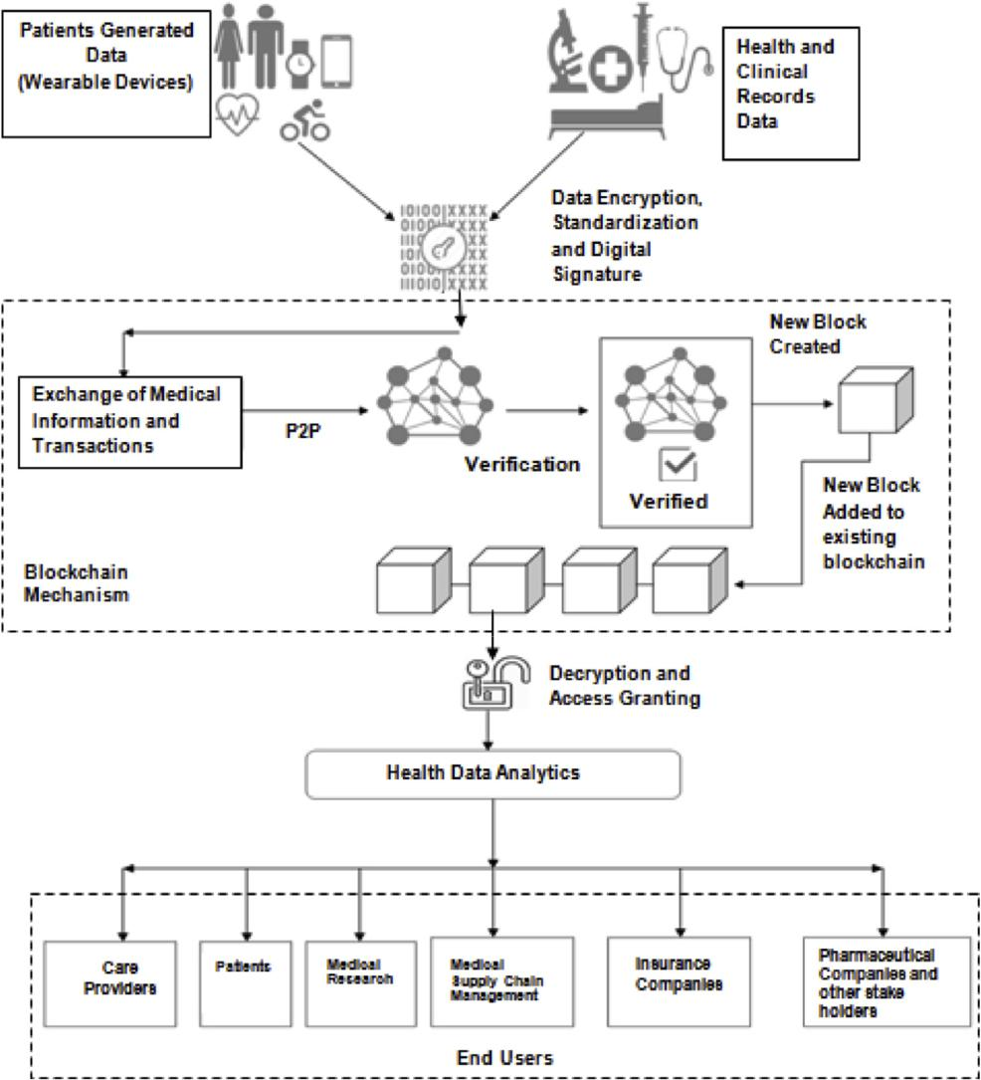

Source: Tripathi, G. Abdul Ahad, M. Paiva, S. (2019). S2HS- A blockchain based approach for smart healthcare system: Healthcare. Elsevier.

Blockchain
The concept of blockchain often comes with Bitcoin so , blockchain is considered as distributed ledger, i.e., a chain of blocks, which stores transactions by packing them into blocks in a chain. The chain links blocks with a cryptographic hash chain, which keeps growing as long as new blocks are created and maintained.
It is a technique to enable a type of modern financial systems that tracks transactions/assets without needs of the centralized party.
One of the representative characteristics of blockchain is decentralized computing with a tamper-resistant feature. The reason of having this characteristic is that no central authority is configured in a blockchain system. A blockchain system is maintained by communications between miners in a distributed network. Data stored in blockchain cannot be falsified once the data are written and stored in a block. In addition, blockchain somehow provides anonymity in a sense where miners can choose multiple public keys to generate identities and participate in blockchain mining.
In Bitcoin, mining, e.g., proof-of-work (PoW) and proof-of-stake (PoS), is a way of forming consensus even though an untrustworthy network maybe adopted. A winning miner is periodically selected to create the succeeding block. In order to encourage miners to keep mining, a few incentive mechanisms are designed, such as Bitcoin and Ether.
Basically, blockchain systems can be categorized into three fundamental types, involving public, consortium, and private blockchain systems. These three types of blockchain systems are used in various implementation scenarios, depending on network scale, miner invitation rule, and security level. In general, public blockchain offers a pure decentralized computing environment; thus, public blockchain is extensively implemented in general purpose financial systems, e.g., Bitcoin blockchain. It has a low requirement towards miner. Differently, private blockchain resides within a single institution, even though it abandons a full decentralized computing setting. It has been widely believed that private blockchain is a type of centralized computing approach. Finally, consortium blockchain fits in a compact cooperation between enterprises/organizations, as it positions the mechanism between public and private blockchain systems.

Blockchain Applications

Blockchain applications are under extensive discussions, as technical communities and commercial giants are actively marching towards service directed systems with specific application requirements. Such systems will enable users to obtain services with more promising features. Originally, blockchain is applied in Bitcoin as a tentative way of conducting financial transactions. The fact that a trusted third party is no longer needed is so fascinating that many blockchain applications as a payment method are proposed. Even banks are using it to reconcile banking records happened among them.
Blockchain is mainly used as an immutable ledger in a system where entities lack trust with each other. Given that a centralized storage solution is becoming questionable and inefficient. A blockchain-based solution can improve system transparency, provide record tamper-resistance, and establish trust between entities.
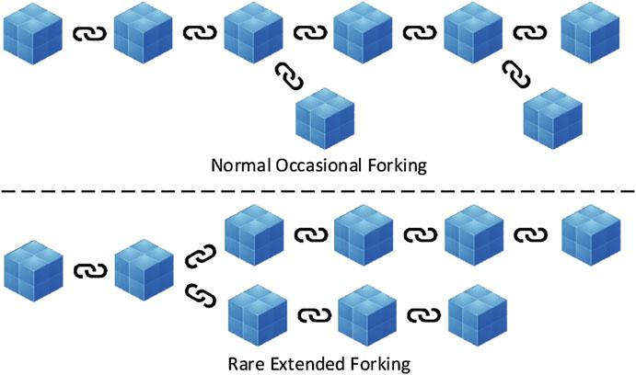
Fig.(2): Different types of Blockchain

Source: Zhu,L. Gai,K. Li, M. (2019). Blockchain and Internet of Things: Blockchain Technology in Internet of Things. Springer.

Blockchain Technology
A blockchain is basically a growing list of records, called blocks, which are linked using cryptography. Each block contains a cryptographic hash of the previous block, a timestamp, and transaction data (in this case the MRIs expressed in terms of automata).
A blockchain is a decentralized, distributed and public digital ledger that is used to record transactions across many computers so that any involved record cannot be altered retroactively, without the alteration of all subsequent blocks. This allows the participants to verify and audit transactions independently and relatively inexpensively. A blockchain database is managed autonomously using a peer-to-peer network and a distributed times-tamping server. They are authenticated by mass collaboration powered by collective self-interests. Such a design facilitates robust workflow where participants’ uncertainty regarding data security is marginal. The use of a blockchain removes the characteristic of infinite reproducibility from a digital asset. It confirms that each unit of value was transferred only once, solving the long-standing problem of double spending. A blockchain has been described as a value exchange protocol. A blockchain can maintain title rights because, when properly set up to detail the exchange agreement, it provides a record that compels over and acceptance.

Blockchain as a Platform
Digitalization refers to the digitization of processes and information alongside improvements, innovations, and reinventions that are enabled by increasingly powerful information technology. Today, nearly every industry sector is affected by digitalization and is facing threats and opportunities through new possibilities. With the rise of the digitalization, the platform approach has become the dominant strategy for large companies to operate an extensible, digital medium of exchange for products, information, and services. A large share of companies with the highest market capitalization based their business on platforms (e.g., Apple, Alphabet, and Amazon). The earlier evolutionary stages of today’s digital platforms were two-sided markets, where two groups of users exchanged goods and every internet user could take the role of either a buyer or a seller (e.g., eBay).
- Given the definition above, we can derive features that distinguish a platform from a two-sided market: The openness to innovation through third-party developers. That is, platforms provide application programming interfaces (APIs) which grant developers access to core functionalities provided by the platform for integration of extended functionality, external services, or platforms. A recently emerging type of digital platforms is blockchain systems.
- From an abstract perspective, blockchain systems can be analyzed on two distinct layers: the fabric layer and the decentralized application layer (dapp or application layer) according to Glaser (2017). The fabric layer comprises the P2P communication, consensus, and database management components. The application layer includes all services and features implemented in the form of smart contracts and is relying upon the functionalities provided by the fabric layer. Application layer services can be (re)used by other users in the same blockchain system. A smart contract- based service, for example, can require services of other smart contracts or might require token transactions on the underlying level for performing its service.
Fig.(3): Blockchain Systems as Open Digital Platforms
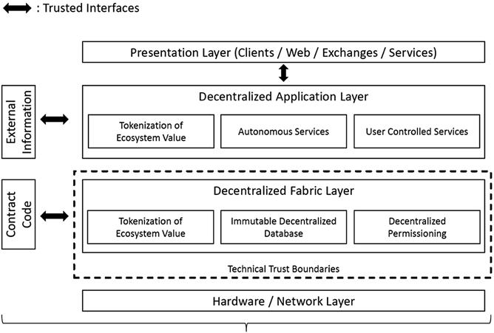

Source: Glaser, F.Hawlitschek, F. and Notheisen, B. (2019). Blockchain as a platform: Business transformation through blockchain. Springer.

Blockchain in Healthcare
The healthcare data is confidential by nature, and every step must be taken to thwart any attack on the data , to sustain an extensive integrated healthcare system , it must be both secure and convenient.
Blockchain technology provides such a solution by offering a distributed network of nodes, where if one or more nodes are compromised, the integrity of the overall system remains intact.
The conventional data sharing systems are different from the blockchain-based systems in that the conventional ones are centralized and have an inherent problem of a single point of failure. There are certain data-related challenges in the Indian healthcare system, which are itemized as follows:
- Patient identification is one such challenge because each provider in the country has its idiosyncratic way of identification.
- Unconnected data is another major problem that exists in the current healthcare ecosystem. The patient identification number and health information are the two crucial elements of the patient’s portfolio.
- The payer and the provider often do not have any formal connection for efficient health information exchange.
- Patients are denied ownership of their health data, and the ownership stays with the provider itself.
- These providers do not share this information with other providers, which leads to the duplication of the data.
Fig.(4): Human - made reasoning: different client mind.
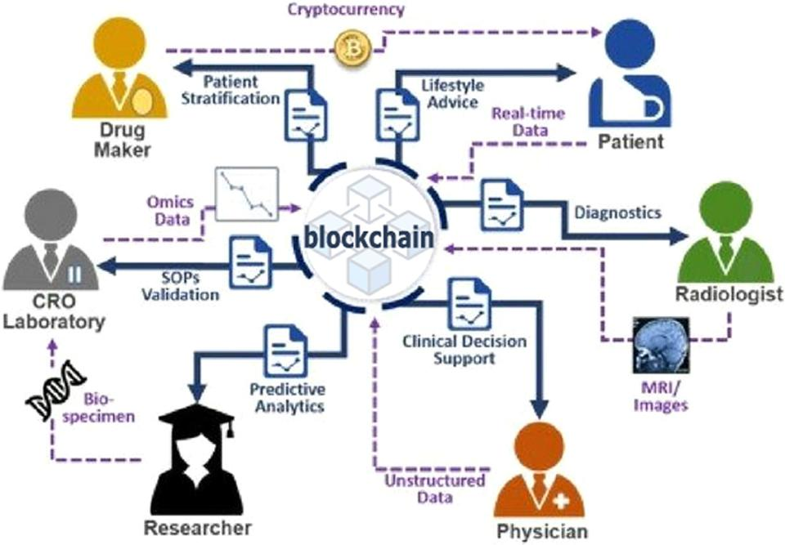

Source: Singh, H. (2018). Technology Trends in HealthCare App Advancements. Theninehertz

Blockchain and IOT in Healthcare
Various blockchain architectures can improve the services provided for the healthcare system. Fig.(5) represents a blockchain combined with IOT technologies that enables the healthcare facilities to have efficient and accurate record management, which is critical. The entire process with the various components from the time of collecting real-time data of patients using IoT until providing a suitable drug that ensures the satisfaction of the patient is described. The blockchain is utilized as a structure to manage the electronic medical records of the patients. The structure is divided into three categories of contracts, which are Registrar Contract (RC), Patient–Provider Relationship Contract (PPR), and Summary Contract (SC). RC is used to transform the identification of participants to their associated Ethereum address identity, and PPR is generated between two nodes in the system for storing and managing the medical records of patients. SC is responsible for retrieving the history of medical records for patients and indicating all the participant’s previous and existing activities with other nodes in the system. A unique framework to maintain the exchange of health information that combines the health organizations, institutions and patients is illustrated in.
Fig.(5): Blockchain in storing Electronic Health Records
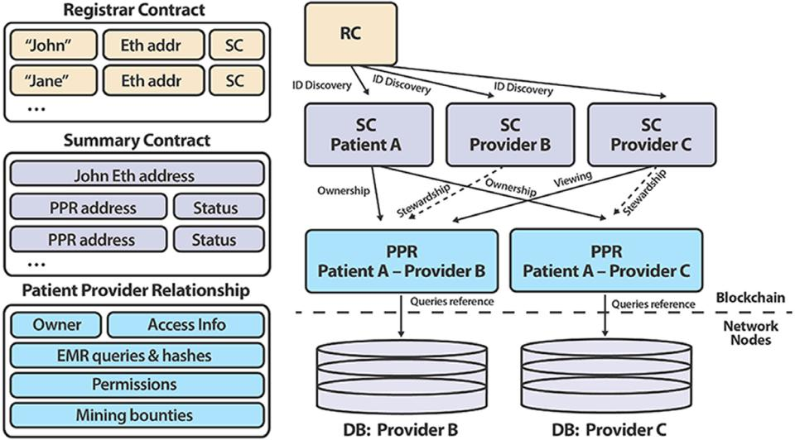

Source: Ekblaw, A. Azaria, A. Halamka,J. Lippman, A . (2016). A Case Study for Blockchain in Healthcare: “MedRec” prototype for electronic health records and medical research data. IEEE.

Interoperability (Data Exchange)
The Health Information and Management Systems Society defines interoperability as " the ability of different information technology systems and software applications to communicate, exchange data, and use the information that has been exchanged".
For healthcare, interoperability has several potential benefits like:
- Communicating systems can improve operational efficiency.
- Reducing time spent on administrative tasks like manually entering data received from faxes.
- Reduce duplicate clinical interventions like imaging studies or lab orders.
- Decreasing overall health system cost.
- Decreasing waste.
- Improving patient safety by reducing the exposure to radiation or invasive procedures.
- Improve clinical care, by facilitating improved access to relevant, longitudinal clinical data at the point-of-care.
While there are mixed results from empirical studies looking at specific interoperable implementations, for example, state-level HIEs , the overall goal of interoperability is a necessary component of cost effective, universal clinical care.
Interoperability in healthcare has traditionally been focused around data exchange between business entities, for example, different hospital systems.
However, there has been a recent push towards patient driven interoperability, in which health data exchange is patient-mediated and patient-driven.
Patient centered interoperability, however, brings new challenges and requirements around security and privacy, technology, incentives, and governance that must be addressed for this type of data sharing to succeed at scale. In this paper, we look at how blockchain technology might facilitate this transition through five mechanisms:
- Digital access rules
- Data aggregation.
- Data liquidity.
- Patient identity.
- Data immutability.
We then look at barriers to blockchain-enabled patient-driven interoperability, specifically clinical data transaction volume, privacy and security, patient engagement, and incentives. We conclude by noting that while patient-driving interoperability is an exciting trend in healthcare, given these challenges, it remains to be seen whether blockchain can facilitate the transition from institution-centric to patient-centric data sharing.
The healthcare interoperability landscape is generally centered around business entities, like hospitals, private clinics, and pharmacies, and data is typically created and fired within the information system that creates it (for example, a hospital's electronic health record).
Exchange is often motivated by financial incentives or regulatory pressure , and numerous efforts exist to encourage better health data liquidity.
Fig.(6): Interoperability for clinical electronic healthcare record(EHR) data: Bi-directional clinical data exchange.
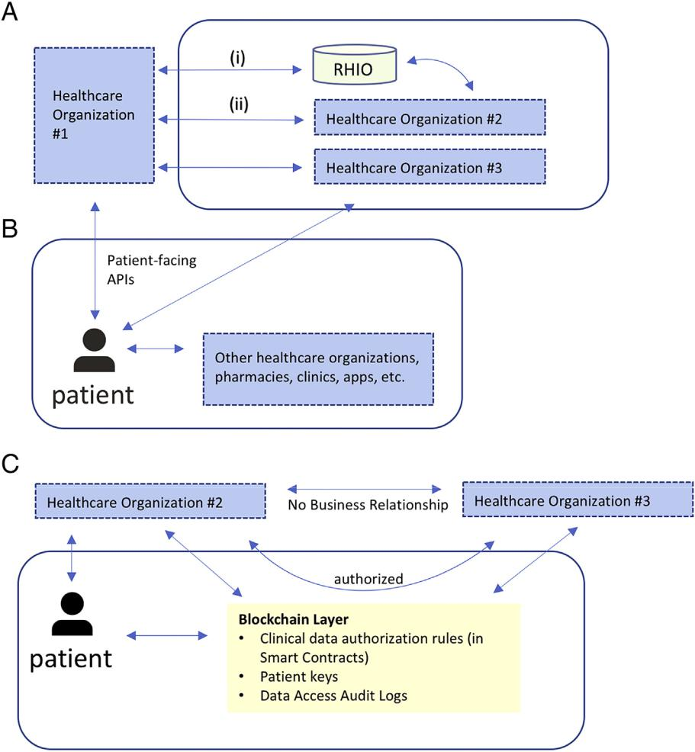

Source: Gordon, W. Catalini, C. (2018). Blockchain Technology for Healthcare: Facilitating the Transition to Patient-Driven Interoperability. Elsevier.

(A) Example of institution-driven interoperability for clinical EHR data. Bi-directional clinical data exchange occurs (i) through an intermediary like a Regional Health Information Organization (RHIO) or (ii) directly between health care organizations with specific business agreements. In both cases, data interfaces are entity-to-entity, not entity-to-patient. In this example, since organization #2 and #3 do not have a specific relationship, there is no bi-directional data flow; providers from organization #2 can request data from organization #3 via one-off requests (like a fax). If a patient receives care at all three organizations, their health data will be scattered across all three EHRs.
(B) Example of patient-driven interoperability. Data sharing centers on the patient; in this example, using patient-facing APIs, a patient can directly retrieve their clinical EHR data from organization #1 and organization #3. Once retrieved, the patient can share with other organizations directly. Data flow can be bidirectional. RHIOs and entity-to-entity relationships may still exist as parallel functions.
(C) Blockchain-enabled patient-driven interoperability. In this example, the patient can still retrieve data directly from organization #2; however, through blockchain-enabled smart contracts, the patient can authorize sharing of clinical EHR data between organization #2 and organization #3, which do not have a formal business relationship. The blockchain layer stores these authorization rules, along with patient public keys (to ensure entity resolution), as well as data access audit logs. Each organization will manage linking a patient's public key to their own internal enterprise master patient index system independently, and patients can update the smart contract-driven authorization rules as appropriate (for example, adding a new institution if they are seeing a new provider).

Application of Blockchain in Magnetic Resonance Images(MRI)
In Blockchain Technology, Equivalence checking is the process of determining whether two systems, expressed using a process algebra, are equivalent to each other according to some mathematically defined notion of equivalence. It is typically used to verify if a system design conforms to its high-level service specification.
We propose a novel application of equivalence checking in an emerging field such as medical imaging security.
In particular, once modeled MRIs as labeled transition systems, formal equivalence checking is exploited to find relationships between the states of the generated automata. The states of the automata are built from a set of radiomic feature gathered from the MRIs.
Labeled transition systems can model a piece of software at various abstraction levels. The lower the abstraction level, the more implementation details are present. At high abstraction levels, such details are deliberately left unspecified. Binary relations between states are useful to compare labeled transition systems, possibly at different abstraction levels.
Fig.(7): The Proposed Method for MRI data exchange
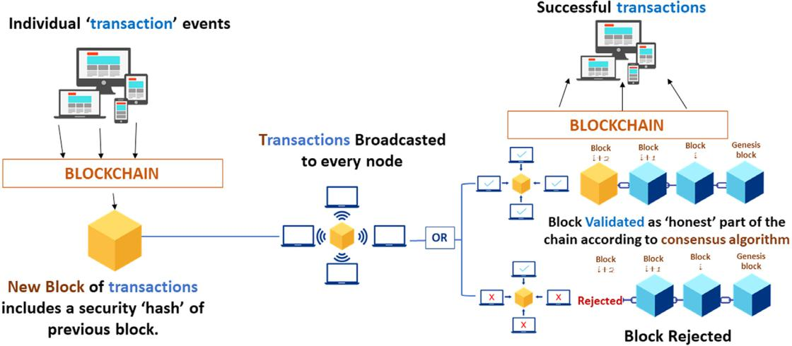

Source: Farouk, A. Alahmadi, A. Ghose, S. and Mashatan, A. (2020). Blockchain platform for industrial healthcare: Vision and future opportunities. Computer Communications. Elsevier.

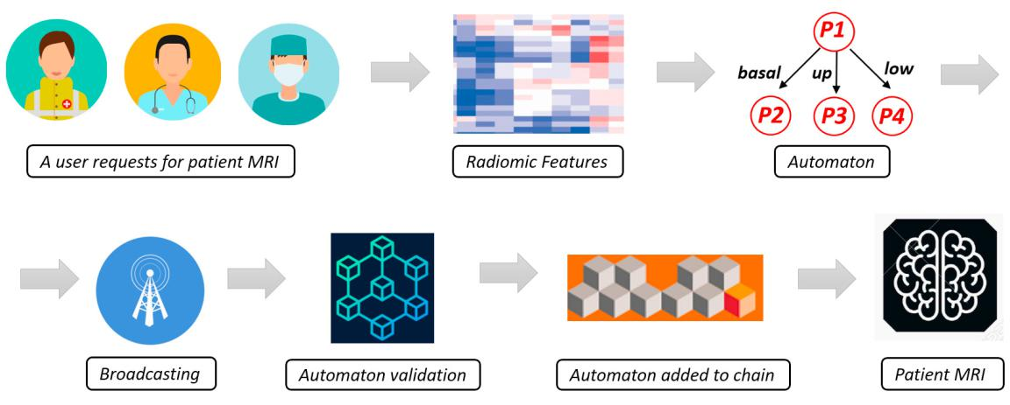
Fig.(8): MRI patient journey

Source: Brunese,L. Mercaldo,F. Reginelli,A. Santone,A. (2019).A Blockchain Based Proposal for Protecting Healthcare Systems through Formal Methods. Elsevier.
The users of hospital networks are basically doctor, nursery and technicians which can request for patient magnetic resonance images (MRI). The proposed method is aimed to perform a distributed verification of the information transiting over the hospital network. In fact, when a new set of MRIs are generated, for instance by a MRI scanner, the radiologist from its host is reading the images. Once the MRIs are received from the radiologist host, a check is performed with the aim to guarantee the MRIs integrity. In fact, the MRIs stored in the sender side (in this case the medical equipment which generated the MRIs) and the ones in the receiver one are represented in terms of automata by means of radiomic features and then by exploiting formal equivalence the automata similarity is verified. We consider as radiomic features the so-called shape features i.e., features independent from the gray level intensity distribution in the cancer region of interest (i.e., ROI). Shape features are derived from the approximated shape defined by the triangle mesh. This mesh is generated using an adapted version marching cubes algorithm where a 2 × 2 square is moved through the mask space. For each position, the corners of the square are then marked “segmented” (1) or “not segmented” (0). Vertices (points) are first defined as points halfway on an edge between a voxel included in the ROI (i.e., Region Of Interest) and one outside the ROI? . By connecting these vertices, a mesh of connected triangles is obtained, with each triangle defined by 3 adjacent vertices, which shares each side with exactly one other triangle. Once the radiologist has seen the MRIs its host represents a candidate for the verification and the automaton generated from this host is added to the chain of verified automata. When a new host will ask for the same patient MRIs, the equivalence checker will perform the comparison between the medical equipment host, the radiologist one and the MRIs received from the new host. In case the equivalence checker outputs true for the related automata generated by the received MRIs, this host will represent a new node to perform the equivalence checking. In this way, for each host requiring the MRI data, the successfully equivalence checking verification will add a new automaton to the chain. The proposed method is distributed: in fact, every equivalence checking computation is performed on the related host node that initially required the MRIs.

Enhancing Privacy for Patients Data

Stored information and patient-generated health data, is highly valuable technological innovations in the healthcare industry have led to the development of wearable devices, including smart watches, fitness bands, trackers and in-built body chips that monitor patient data. These wearable devices have contributed to an increase in the flow of data generated by patients. Blockchain technology offers solutions to the challenges that come with the increase in healthcare data
Swiss digital health start-up Health bank provides blockchain solutions, providing the following capabilities to its users and facilities:
- The sharing and handling of healthcare data and patient transactions.
- The retrieval of private patients’ information including heart rate, sleep patterns, blood pressure, eating, consumed medicines, health history, and lifestyle habits.
- Data saving and availability of data for medical research; and the storing and managing of facilities’ data in a secure location.
Even with all of these capabilities, Health bank still offers users sovereignty of their information; users are able to save their data and to make it available to medical research. Individual medical data stored at Health bank has proven to be of great significance to patients and donors. In addition, blockchain allows medical data accessible to researchers to be followed during the research, which could be of monetary value to the patient and a source of side income if they choose to share their data for research. Health bank has contributed significantly to the health sector and medical research, assisting in the digitization of digital business and digital health initiatives.

Benefits of blockchain in the healthcare
- The foremost advantage of the blockchain in healthcare is received from the intrinsic property of blockchain being immutable, Thus the compromised computer nodes would have recovered their data from any of the majority of uncompromised nodes.
- The healthcare ecosystem in India can leverage is the reestablishment of trust by promoting a 100% trustless environment. Blockchain requires multiple copies of the data to be available simultaneously at different nodes.
- This seamless healthcare data exchange makes it possible to use this holistic data for policy formulations and quality healthcare services by keeping patients at the center and making every stake-holder, patient-payer-provider (PPP), accountable, and transactions transparent.
- It can restructure the interoperability of healthcare databases, offering improved access to patient medical records, prescription databases, device tracking, and hospital assets, together with the complete life cycle of a device within the blockchain infrastructure. Few key benefits of blockchain technology in the healthcare sector are explained below:
- Protection of crucial medical data: An imperative aspect of blockchain technology that could benefit the healthcare sector is its excellence in decentralization; due to this, a lot of data is kept in small units. If this data had been centralized, the medical records of patients would have been stored in a central server or any specific system, and anyone would have access to the system that could have corrupted all the data. The most modern crypto-graphic features of the blockchain technology facilitate checking of the data authenticity with the help of digital signature and offer infallible security to the data.
- The anonymity of patients: Blockchain offers data transfer service between a node to node, the identity of the patient in the healthcare network remains anonymous, thus making it a more secure and reliable system. Only an authorized person can view the identity.
- Easy access and budget control: The incessant connectivity via level-based permission and easy access incredibly empowers different stakeholders of the healthcare industry. Using automation, manual, and monotonous data handling processes may take advantage of blockchain technology and helps the healthcare industry to pull out the maximum potential of human resources all through different stages and processes.
- Consequently, it boosts human efficiency, and increased efficiency means better output in less time. Blockchain technology also assists in keeping the budget under control, lessening administration costs, and allows better, purpose specific utilization of allocated funds.
- Cost efficient shared access: Smooth and untroubled data sharing across key healthcare providers play a pivotal role by providing benefits such as precise diagnosis, cost-efficient treatments, and ultimately the better treatment for various diseases.
- Active monitoring: As a precise answer, this revolutionary technology enables documenting the transactions in a decentralized record. It augments privacy and brings transparency into the system as well.
- Distributed and Secured Storage of patient's medical and clinical Data.
- Enable Patient Centric System.
- Transparency in Audit Trials.
- Holistic Quality Management and tracking of facilities and services.
- Secured and Transparent Supply Chain Management.
- Trusted and Immutable Control and Management System.
- Promotes patient mediated communication, information sharing and exchange.
- Data is encrypted using blocks forming a chain like structure.
- Remove central node dependency (everyone shares equal rights and privileges).
- Better engagement of patients in every aspect from diagnosis to treatment and cure.

Digital Transformation for Universal Health Insurance (UHI) in Egypt

Egypt is undergoing a major change in its modernization. It is transforming to a digital state to better serve its citizens.
The presidential mandate for the government is to drive citizen centricity.
This means putting citizens at the top of government agenda to sustainably improve their quality of life; that is considering the Egyptian human capital as the most important pillar in the Egyptian Comparative Advantage Strategy.
- Healthcare represents one of the main pillars for effective human capital development.
According to the World Health Organization (WHO), the route to alleviate poverty and strive for prosperity requires governments to consider Universal Health Coverage (UHC) as a fundamental tool.
Egypt, in the pursuit of addressing the healthcare societal challenges, has issued the Universal Coverage Healthcare law and bi-law which was issued since Jan.2018 with the following identified objectives:
- Establish a health map for all Egyptians.
- Quality healthcare services
- Access to all Egyptians
- Full coverage for the healthcare services
- Financially sustainable ecosystem
To achieve the previous objectives, the Universal coverage Healthcare Law and bi-Law was issued on January 11, 2018, which is mandatory for all Egyptians (100 millions ) which includes among its articles that provide Universal health insurance services through three levels which requires three authorities , namely:
- The Universal Health Insurance Authority
- Health Care Authority
- Accreditation and Supervision Authority
This set the necessity of ahead towards the use of an integrated, secure and encrypted electronic system that enables during it, the effective and integrated management of the scope of universal health insurance business at its three levels , It helps in effective monitoring and making available all the information that helps in making decisions.
The covered healthcare law and bylaw divided health care levels as follows:
- The first level: It is the basic health care units and provides primary health care services
- The second level: It includes the stage of diagnosis and treatment and is handled by hospitals of all levels
- The third level: It includes special rehabilitation stage such as specialized kidney centers and cardiac centers Specialized
The scope of work for the universal health insurance system planned to be gradually, it started in PortSaid Governorate as proof of concept (POC).
Stating that The Ministry of Health (MOH) is responsible to implement the project until the establishment of the three authorities.
From the previous, noting that many and many interlocking procedures will integrate to ensure the service provided to the Egyptian citizen.
In Addition , the database for UHI 's beneficiary will be considered the main database for all Egyptians and their services, beside the interconnection between the providers and the different supported places for example the collection process which needs to collect basic data , payment methods from 17 entity (The Ministry of Social Solidarity , Insurance and Pensions Authority,..etc ) ,which implies that establishing UHI based on blockchain is mandatory to provide the presidential vision for of healthcare.
Where the presidential vision of digital transformation of healthcare based on mechanization scheme for the new universal health insurance system is: as it provide managing, activating, integrating, securing, hosting, supporting and maintaining the following systems:
- Insurance Authority Mechanization System.
- Enterprise Management for Automation system (hospitals - primary health care units - primary health care centers) of the Health Care Authority.
- Accreditation and Quality System for Health Service Providers.
- E-health file system for the citizen.
- Electronic portal system for health service providers.
- The beneficiary portal system.
- Customer service system and a center for receiving calls and inquiries (users - service providers).
- Mobile applications for users and health service providers.
- System of e-health applications at the state level (government medical sector - commercial private medical sector).
- maximizing the role of (e-commerce) applications and (citizen engagement in health care) applications and (integration between the government medical sector - the private medical sector) to provide an appropriate health service; And facilitate communication procedures and customer service.
- Application security system including use of (2FA).
- System of the integration platform for the circulation of health and medical information at the country level, which allows the integration of all the aforementioned elements; In addition to providing the analyses and performance indicators necessary to evaluate the health system and support decision making.

UHI as a HUB for Beneficiary Operations
With this diversity and accumulated experiences by the next years we can confidently share a state-of-the-art citizen centric proposition.
- Customer Experience Excellence.
- CEM Practices Assessment & Benchmarking.
- Building a solid CX strategy & brand Promise.
- Measurements & insights.
- Customer journey mapping.
- Create organizational awareness & guidance.
- Build people capabilities through CEM training programs.
- Credit Management.
- Credit Management hierarchy.
- Credit Management & life cycle management.
- Credit Management strategy.
- Fraud.
- End 2 End billing.
- Life Cycle Management.
- Complaints Management policies.
- Complaints Channels.
- Retail Complaints process.
- Retention/Compensation matrix.
- VIP treatment.
- Voice of customer.
- Improve customer lifecycle.
- Retention & Change Management.
- Social Media & Online.
- Customer support model.
- Operations KPI’s (Quality, AHT, .. etc.).
- How to proactively hunt the influencers.
- Brand monitoring & analysis.
- Social Media insights.
- How to maximize the brand reach.
- ROI from Social Media.
- How to get leads from social media.
- E-shop.
- Consumer online activities.
- Enterprise online activities.
- Mobile Apps impact.
- Enterprise Account Management.
- End 2 End Enterprise Care model.
- Enterprise activation model.
- Account Management model (Segment Account Angel).
- Collection model.
- Customer delight center.
- Back office model.
- Credit management.
- Big Data & Analytics.
- Big data models.
- Data mining.
- Achieve customer intimacy through data mining.
- Segmentation.

For providing all the above there are many stakeholders must to be involved in one pole whit detailed policies which lead to issue the law1895, 2019 to establish all the needed stakeholders for recent UHI work and for future citizen services work, covering the main objectives consists of:
- Ministry of defense (Security , hosting issue )
- Ministry of finance ( financial sustainability )
- Ministry of Health ( owner )
- Ministry of telecommunication and information technology (digital transformation )
- Administrative Control Authority (Citizen database ) .
- Ministry of military production (president of committee).

Patient Journey
Fig.(9): UHI Patient journey
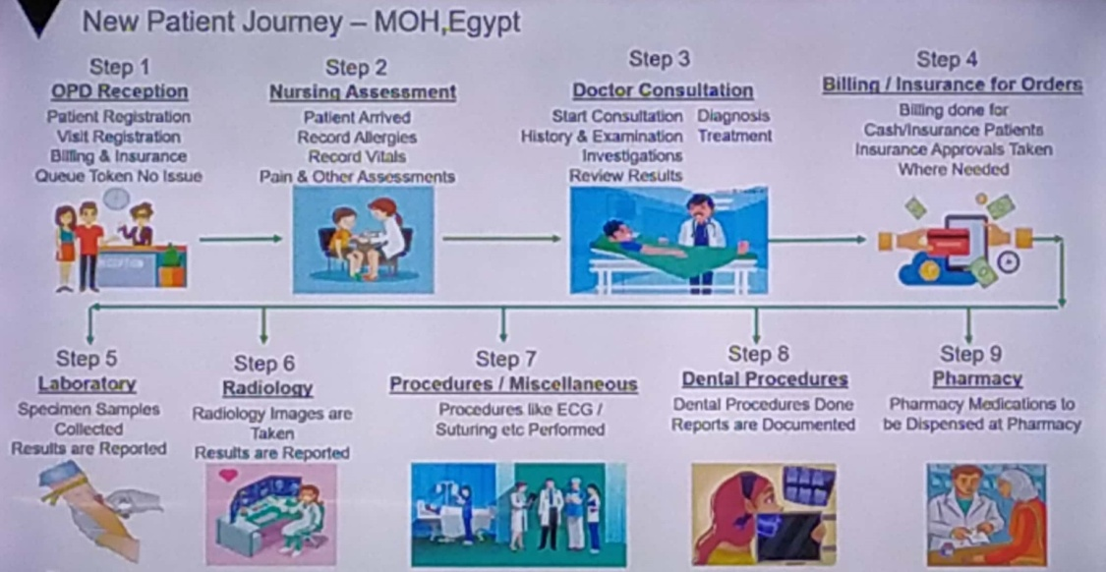
Source: Digital Transformation for universal health insurance proposal: Egyptian government (Not published )
to accomplish the desired UHI services we must begin with change management process which include three levels:
- Assessment
- Planning
- Monitoring which have the more impact in sustaining the UHI services.

UHI program architecture
Fig.(10): UHI Program architecture

Source: Digital Transformation for universal health insurance proposal: Egyptian government (Not published )

Healthcare Data Exchange Benefits
- Providers
- Clinical decisions based on more complete knowledge .
- Better knowledge translates to better care.
- Accurate relevant data.
- Real time, rapid access from multiple locations, anywhere, anytime.
- Clinical reference data with common codes.
- Safety and detection of interactions.
- Government Sector
- Management reports.
- Resource allocation.
- Policy based on data.
- Semantic interoperability of health information across services delivery points.
- Objective analysis of results and benefits.
- Citizen / Beneficiaries /Patient
- Access to relevant personal health information
- Increased awareness and involvement of patient in care delivery.
- Increased safety.
- Healthcare alerts, interactions.
- Improved quality of care.

Conclusion and Future Work for UHI in Egypt

After the successful story of operating POC of UHI in PortSaid governorate to implement the healthcare system on 34 units and center and 11 hospitals under the umbrella of universal health insurance for a period of three months and present the whole program in front of our president with all learned lessons and how to conclude benefits from them in implementing the rest of the stages of universal health insurance and take the launching signal for the program with the beginning of 2020 and to go into Implementation on all governorates of Egypt gradually according to the planned phases and the new strategic visions, where each phase covers strategic and security areas that cover our citizens and integrates with sustainable development projects in these governorates .
with the following Objectives to be achieved .
- Redevelop some of the foundations of the solutions used in the POC to suit the geographical distributions of the governorate residents and how to facilitate dealing with their culture and avoid resisting change and dealing with it professionally and easily, including the following core components:
- Patient Portal, which will enable all beneficiaries data to patients allowing them to can review their patient history , diagnoses and claims.
- Communication portal.
- Master Data Registry(MDR), which utilizes any clinical components information like drugs, ingredients, services,..etc.
- Transaction Management Bus(TMB), which acts as a carrier transceiver between components, transactions, and messages.
- Expert Management System(EMS), which include predefined rules, police, benefits, price list, plans and the basic information lists(Providers, clinics, dental, services, consumables, procedures, and diagnosis)
- Begin the integration with of collection ministries .
- Begin integration with the national data bases of Egypt
- Begin applying the financial system to ensure the financial sustainability of the system.
- Continuous development of the information and technological infrastructure of the governorates, respectively.
- Ongoing training for participating medical teams
- The agreement to launch a unified smart card for citizen services(Meeza card ), as it starts integrating health insurance services with family cards (Supply card ) with support for farmers in addition to social solidarity services of solidarity and dignity, and all other services are integrated in the same smart card, thereby ensuring that support reaches those who are entitled to and the freedom of the citizen to use support in The service he needs according to his health and life priorities.
- Leading the change with great craftsmanship in light of the conditions of the Corona virus pandemic crisis and maintaining the psychological stability of the expedited medical teams attached to the universal health insurance system.
To achieve the previous objectives we must produce our blockchain based solution hence blockchain technology in combination with the other modern technologies has the power to transform the existing smart healthcare systems from a centralized and vulnerable system to a distributed, decentralized and secure system that can help in improving the quality of medical and other related services as:
- Helps to provide transparent data to all stakeholders while maintaining the privacy of the patients.
- Integrate all required data, files from different supportive ministries.
- Puts a check on the expensive manual inefficiencies.
- Provide inexpensive and secure services to insurance companies, drug supply chain, pharmaceutical companies and medical researchers.
- The research can be directed towards achieving scalability in the S2SH.
- Motivate the development of universal standards for the adoption of blockchain healthcare.
- The issues related to network bottlenecks, scalability and widespread adoption of blockchain system needs to be resolved.
- The applications of blockchain in healthcare are still at an primary stage of study but it has a great potential to transform the healthcare .
- It will improve the security, management, and analysis of healthcare big data.
- Avoid the leakage of patient personal information.
- Healthcare executives planning IoT and blockchain implementations should consider two supplemental technologies that can speed up adoption and time to value.
- The first is the use of AI, which aggregates and then extracts insights by recognizing patterns and correlations across large volumes of data.
- Hybrid clouds are the second key to a strong IoT and blockchain foundation.
- These new hybrid cloud customer models provide highly scalable public-cloud applications and services while keeping clinical data behind enterprise firewalls to confirm organizational and regulatory requirements.

Fig.(11): The desired Electronic Health blockchain based platform in Egypt
Source: Digital Transformation for universal health insurance proposal2: Egyptian government (Not published )

References
- Alam Khan, F.and others (Khan, F. et all, 2020). Asif, M. Ahmad, A. Alharbi, M. Aljuaid, H. (2020). Blockchain technology, improvement suggestions, security challenges on smart grid and its application in healthcare for sustainable development: Sustainable Cities and Society. Elsevier.
- Brunese,L. Mercaldo,F. Reginelli,A. Santone,A. (2019).A Blockchain Based Proposal for Protecting Healthcare Systems through Formal Methods. Elsevier.
- Ekblaw, A. Azaria, A. Halamka,J. Lippman, A . (2016). A Case Study for Blockchain in Healthcare: “MedRec” prototype for electronic health records and medical research data. IEEE.
- Farouk, A. Alahmadi, A. Ghose, S. and Mashatan, A. (2020). Blockchain platform for industrial healthcare: Vision and future opportunities. Computer Communications. Elsevier.
- Glaser, F.Hawlitschek, F. and Notheisen, B. (2019). Blockchain as a platform: Business transformation through blockchain. Springer.
- Gordon, W. Catalini, C. (2018). Blockchain Technology for Healthcare: Facilitating the Transition to Patient-Driven Interoperability. Elsevier.
- Pandey, P. Litoriya, R. (2020). Implementing healthcare services on a large scale: Challenges and remedies based on blockchain technology: Health Policy and Technology. Elsevier.
- Singh, H. (2018). Technology Trends in HealthCare App Advancements. Theninehertz
- Tanwar , S. Parekh, K. Evans , R. (2020). Blockchain-based electronic healthcare record system for healthcare 4.0 applications: Journal of Information Security and Applications. Springer.
- Tripathi, G. Abdul Ahad, M. Paiva, S. (2019). S2HS- A blockchain based approach for smart healthcare system: Healthcare. Elsevier.
- Zhu,L. Gai,K. Li, M. (2019). Blockchain and Internet of Things: Blockchain Technology in Internet of Things. Springer.

