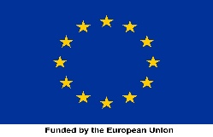
Investment Case Towards Ending Unmet Need for Family Planning in Egypt by 2030

Current situation
- The birth rate decreased from 5.3 children per woman in 1980 to 2.85 in 2021.
- The rate of use of family planning methods increased from 56.9% in 2014 to 64.7% in 2021.
- Unmet need for family planning remains at 13.8%
Goal
Ending the unmet need for family planning (FP)by 2030 through increased investment in the program.
Investment
Invest additional EGP 825 million over the next seven years, bringing the total FP intervention cost to EGP 11.1 billion to achieve the 75% CPR.
Scenarios

Three distinct scenarios were modeled to illustrate the impact of the goal. These scenarios showcase varying Contraceptive Prevalence Rate (CPR) and modern Contraceptive Prevalence Rate (mCPR) levels, detailing the resulting health outcomes, reductions in fertility rates, and unmet need and the necessary resources to expand FP interventions to achieve these diverse levels of success.

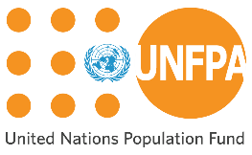

Expected Results
- Compared to the status quo, scenario 2 (75% CPR by 2030) could prevent around:
  - 1.5 million unintended pregnancies.
  - 733k unsafe abortions.
  - Unmet need for FP 8.6%

Key messages
- Family planning significantly affects health and development outcomes.
- Increased investment in family planning is necessary to eliminate unmet need.
- Using modern family planning methods saves lives and prevents unwanted pregnancies.
- Reduced unmet needs by 2030 contribute to achieving several SDGs
- Funding is estimated to fall short by 70% across all scenarios
- Closing the financial gap will require exploring alternative funding sources

Impact
- Improving maternal and child health.
- Empowering women to make informed decisions.
- Promoting social and economic development.

Conclusion
Fully and effectively meeting family planning needs brings many social and economic benefits. The investment case underscores a critical finding across all scenarios: an increasing CPR and utilization of modern contraceptive methods would not only save lives but also avert unintended pregnancies, maternal deaths, and unsafe abortions. This proactive approach is instrumental in preserving potential productive capacity that would otherwise be compromised.

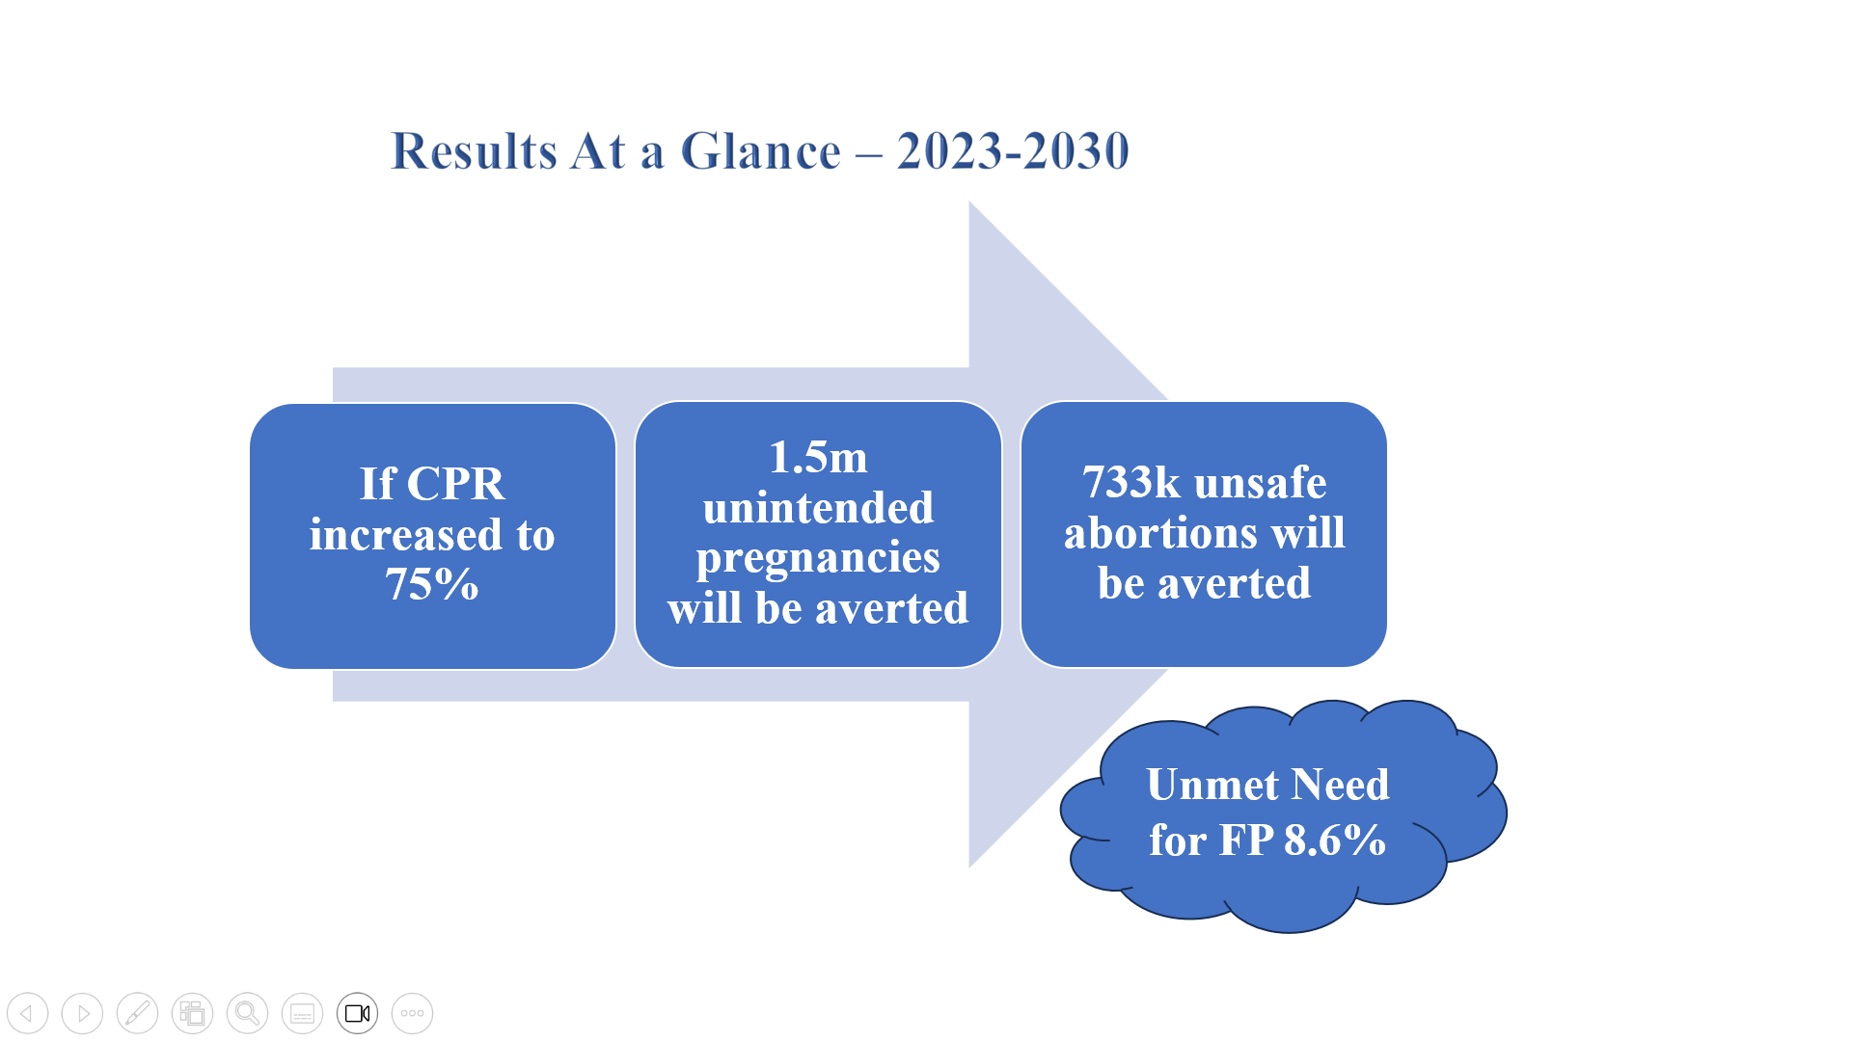

Note: You can review the full Investment Case through this QR code:

Additional Information
- Egypt is the most populous country in the Middle East and North Africa.
- Egypt’s population is 105 million people in 2023.
- The population of Egypt is increasing by 20 million people every 8 years.
- Egypt’s population is expected to reach
124 million by 2032.

